SMS Relay
SMS Relay calls are ideal if you are deaf, can't hear well or have difficulty using your voice. You just need a mobile phone.
This is a text based relay call using the mobile phone network, so you type your messages, send them, wait for a response and read the responses.
This service is only available with a mobile phone connected to a mobile phone network. You do not need a data or internet plan.

How it works
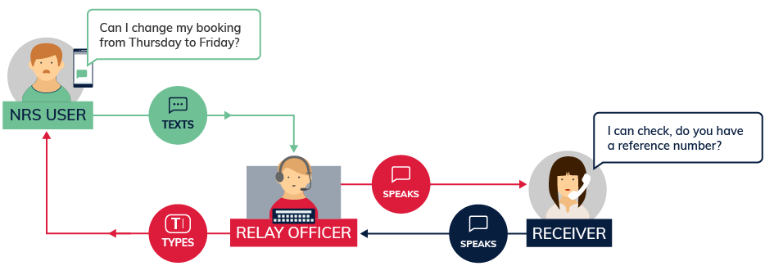
In this type of call, you type your side of the conversation as a series of SMS text messages on your mobile phone and read the responses from the other person, typed by the relay officer, also on your phone.
Relay officers are the central link in the phone call. They stay on the line throughout each call to help it go smoothly, but do not change or interfere with what each person says.

Equipment
All you need is a mobile phone. You don’t need to have internet access or a data plan.
Type a short text message (160 characters) on the phone and read the responses from the other person when the relay officer texts you back.

What does it cost?
Call costs depend on the type of plan you have for your mobile phone. Each SMS to the NRS will cost the same as any other SMS you send.

Further information and useful links:
SMS Relay Fact Sheet
Making a SMS Relay Call Instruction Sheet
Answering a SMS Relay Call Instruction Sheet
Making a SMS Relay Call to Emergency Services Instruction Sheet
NRS Service Features Web Page
Numbers for calling a NRS User
NRS App – Apple App Store
NRS App – Google Play

*The information contained in this document comes from the National Relay Service Australia.

