

# iT and Coffee

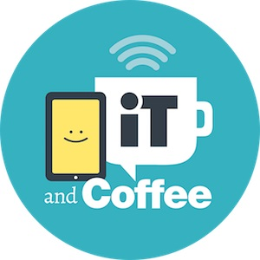

iT and Coffee is a Victoria based company that provide individual, group, and online training resources to help you make the most of your technology and communication devices. They offer set workshops that you can attend, or allow you to decision your own class for a group of people that suit your needs. This service is targeted at seniors, and can be adapted to suit some disability-specific needs. Classes are held at their offices or you can arrange for trainers to come to your preferred location.

## Access Needs:

* Cognition
* Hearing
* Vision
* Speech
* Physical

## Location:

* Victoria (VIC): Camberwell

**T**r**aining Delivery:**

* Groups
* Individual
* Online

## Available Training:

### Technology Classes – Paid Training

These are small, patient, and social classes that address different topics. The classes can change to suit new technology and needs, however some topics include:

* Introduction to the iPad & iPhone
* iPad & iPhone User Group
* Discovering iOS13 and iPadOS
* And many more

For more information on the available classes, visit: [iTandCoffee Classes Web page](https://www.itandcoffee.com.au/classes.html#ios)

To book your own class and select targeted topics for a group of people, visit: [iTandCoffee Book a Class Web Page](https://www.itandcoffee.com.au/book-your-own-group-session.html)

### Private Appointments – Paid Training

iT and Coffee offer private appointments to be held at their offices or your place, allowing for a personalized approach to technology training. Appointments are priced according to the type of assistance you require - whether you just need help to get started with the basics, or whether you need a higher level of technical expertise to address your questions and issues.

For more information on appointments, visit: [iTandCoffee Appointments Web page](https://www.itandcoffee.com.au/help-with-technology.html)

### Online Content

They also provide guides, videos, and resources for those not located in Melbourne or prefer to learn at home.

For more information on online content visit: [iTandCoffee Online Content Web Page](https://www.itandcoffee.com.au/online-content.html)

## More information

For more information on the training available and to browse available courses visit: [Lynda.com Web Page](https://www.lynda.com/)

For additional information call 1300 885 420 or email [enquiry@itandcoffee.com.au](mailto:enquiry@itandcoffee.com.au)