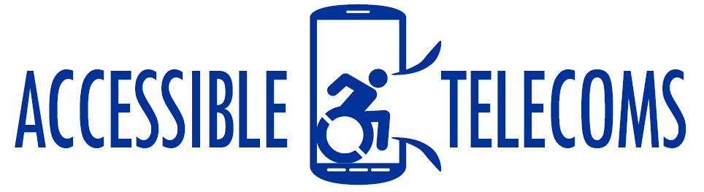

# Oscar’s TechHUB



Oscar’s TechHUB is a NDIA registered business that specialises in phone and tablet repairs, website design, and general IT solutions. Through the NDIS program, Oscar’s TechHUB has partnered with Just Right Therapy Services and LNH Physiotherapy to provide information on, access to, and training in the use of a number of assistive technology devices. Training sessions are offered on-site at their Cooma location, or their experienced staff can travel to locations throughout NSW and ACT. They offer group or individual face-to-face training sessions as well as online resources, with different sessions offering beginner, intermediate, or advanced levels of training.

## Access Needs:

* Hearing
* Speech
* Physical

## Location:

* Australian Capital Territory (ACT)
* New South Wales (NSW): Cooma

## Training Delivery:

* Groups
* Individual
* Online

## Available Training:

### NDIS Assistive Technology Program – Paid Training

As a NDIA provider, Oscar’s TechHUB works closely with their client’s physiotherapists, occupational therapists, and plan managers to ensure individuals living with hearing, speech or physical impairments have access to assistive technology. The offer information and training on how to use a variety of products, as well as providing a number of products for loan or sale such as:

* Voice output devices
* Communication devices
* Laptops, iPads, iPhones, Tablets, Desktops
* Drawing/Graphic pads for computers
* Text-to-speech equipment
* Speech-to-text equipment
* Software downloads
* Tech lessons/training/general repairs

The paid training sessions provided by Oscar’s TechHUB focus on how to use a variety of technological devices, including Apple and Android Phone Devices and Tablets. These sessions are designed to meet the needs and answer the questions of their clients, providing information on how to use these devices to develop the skills and confidence to use technology for business, socializing, and in daily life.

## More information

More information on the products and training available at: [Oscar's TechHUB Web Page](https://www.oscarstechhub.com/)

For additional information please call 0447 465 212 or email [admin@oscarstechhub.com](mailto:admin@oscarstechhub.com)