Large Keyboard Apps
Large Keyboard Apps let you adjust the size of the keys on your keyboard, allowing you to easily see and press the key buttons. This will reduce the number of mistakes you make whilst typing. This app is helpful for people with visual and/or fine motor impairments.
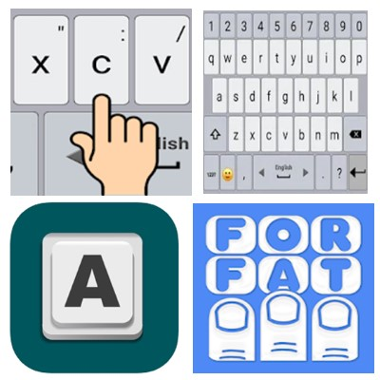

Access Needs:
- Vision
- Physical

Applications:

Classic Big Keyboard for Android
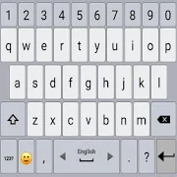
Compatibility: Android 4.1 and up.
Features:
- Adjust the size of the keys on your keyboard
- Change the sound and vibration of typing
- Select a theme
- Select the favourite top and bottom rows of the keyboard
- Long press the ‘Enter’ key to access the keyboard settings
- Swipe the spacebar from side to side to change language
Price: Free to install, in app purchases for more features.
You can get this app from the Google Play Store

Huge Keyboard for Android
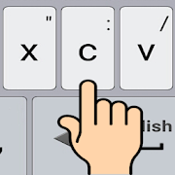
Huge Keyboard app provides you with a bigger keyboard to the one on your device. Make less mistakes and type with ease.
Compatibility: Android 4.1 and up.
Features:
- Adjust the size of the keys on your keyboard
- Select your favourite font of the keyboard
- Change the sound and vibration of typing
- Select the favourite top and bottom rows of the keyboard
- Long press the ‘Enter’ key to access the keyboard settings
- Swipe the spacebar from side to side to change language
Price: Free to install, in app purchases for more features.
You can get this app from the Google Play Store

1C Big Keyboard for Android
1C Big Keyboard for Android is easy to learn – it’s a QWERTY keyboard smartly compressed into extra large keyboard. Designed for people with ‘big’ fingers it can also be used by someone with physical and visual impairments.
Compatibility: Android 1.6 and up.
Features:
- Adjust the size of the keys on your keyboard
- 100% display mode - the entire screen of your device is used as a keyboard
Price: Free to install, in app purchases for more features.
You can get this app from the Google Play Store

Big Buttons Keyboard Standard for Android
Big Buttons Keyboard Standard app has big, easy to read, accurate to press buttons, arranged in a layout that you can learn instantly.
Compatibility: Android 1.6 and up.

Features:
- Big and easy to read keys on your keyboard
- The keyboard layout is exactly like that of a computer. It includes punctation and number keys
- Adjustable keyboard height
- Big Buttons Keyboard Deluxe includes themes, emoji, voice-to-text microphone, word prediction and large cursor keys
Price: Free to install, in app purchases for more features.
You can get this app from the Google Play Store

Big Keys Keyboard for Apple
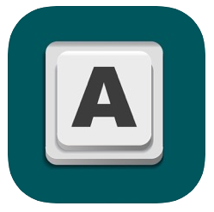
Big Keys is a unique keyboard made for you to easily see all the keys. You can resize the key and emoji sizes to make it the perfect size for you.
Compatibility: iOS 10.2 and up.
Features:
- Adjust the font size and emoji size on the keyboard
- Numeric keypad is also available
- Option to use gestures for typing
- Use emojis as your default keyboard
Price: $5.99
You can get this app from the Apple App Store

