Voice Control Applications
Voice Control applications allows users with mobility and motor impairments to control their device using speech. Common functions include navigating through apps, writing and editing text, and making calls. Some applications allow users to customise the voice controls to suit their needs.
The specific functions the app can control and its reliability will depend on its compatibility with the selected mobile device and the operating system. Please contact your mobile provider or the application developer for more information.
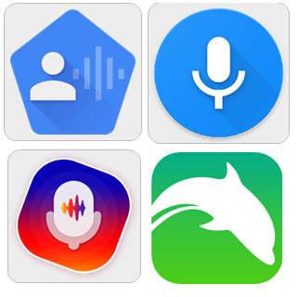

Access Needs:
- Vision
- Physical

Compatibility:
- Each application will require a different operating system to work effectively.

Applications:
- Voice Access
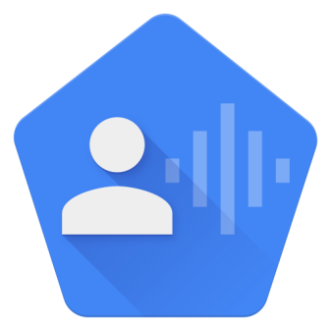
The Voice Access app allows you to control their device, navigate through apps, write and edit texts, and control Google Assistant using your voice. Users can customise the voice controls so that you can tap buttons or adjust controls within apps using your voice. Voice Access assigns numbers to different areas on the screen so you can select an area to open or type in by speaking the number assigned.
Compatibility: Requires Android 5.0 and up.
Prices: Free.
More information at: Voice Access Support Web Page.
You can download this application from the Google Play Store.

- Dolphin Browser– Free
Dolphin Browser is an internet explorer browser that features voice control to search, share on social networks, bookmark favourite websites, and navigate the web on your phone.
Compatibility: Requires iOS 8.0 or later or Android OS dependant on your mobile device
Prices: Free.
More information at: Dolphin Browser Web Page.
You can download this application from the Apple App Store and the Google Play Store.

- Vani - Your Personal Voice Assistant Call Answer
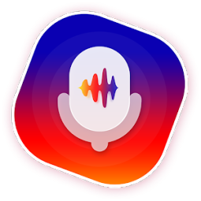
The Vani Voice Assistant app is designed to help individuals accept, decline, and respond to calls and messages only using their voice. This app allows you to create your own voice commands for each function.
Compatibility: Requires Android 6.0 and up.
Prices: Free to download with in-app purchases of $2.29 per item, as at 11/07/2019.
More information at: VANI Web Page.
You can download this application from the Google Play Store.

- Voice Search - Speech to Text Searching Assistant
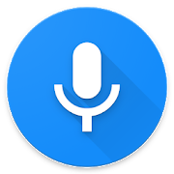
The Voice Search apps is a faster and easier way to search apps, web search, or image search using your voice. It works across apps and allows you to open external communication programs to make calls or send messages.
Compatibility: Requires Android 4.1 and up.
Prices: Free to download with in-app purchases of $2.29 per item, as at 11/07/2019.
You can download this application from the Google Play Store.

