Virtual Braille Keyboard Applications
Braille Keyboard applications are design to allow blind and vision-impaired individuals to effectively communicate using mobile and tablet devices without having to purchase and connect additional hardware. They allow individuals to use the mobile touchscreen to type words and sentences in braille code, which can then be shared to external communication apps.
The apps available have various keyboard layouts, Braille versions, and sharing capabilities.
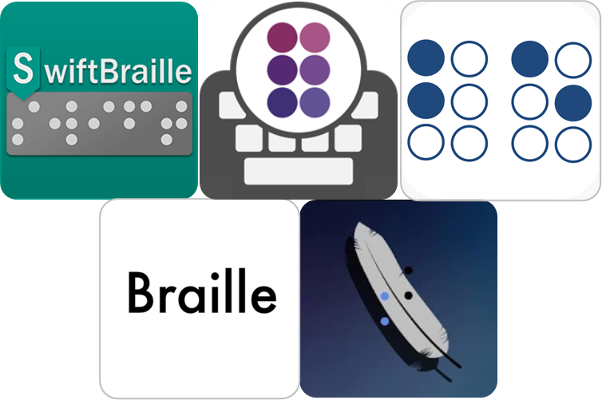
Type of accessory: Application
Access Needs:
- Vision

Compatibility:
- Braille Keyboard apps will only work on mobile devices with a touchscreen. Each application will require a different operating system, which will affect the accuracy and ability of the Braille keyboards.

Applications:
- BrailleEasy
BrailleEasy is a custom touch-screen keyboard that adapts two-handed Brailling into two gestures to allow for efficient communication for individuals with visual impairments. Dot positions can be adapted to suit one-hand typing and braille code can generate English or Arabic writing.
Compatibility: Requires iOS 8.0 or later.
Prices: Free.
More information at: Perkins eLearning Web Page.
You can download this application from the Apple App Store.

- Braille Go
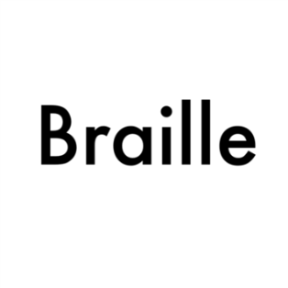
The Braille Go app allows you to type braille words in the braille keyboard and translated words will appear in English. While these texts can be saved in both Braille and English, they can only be exported to communication apps in the form of an excel spreadsheet.
Compatibility: Requires iOS 11.2 or later.
Prices: Free.
You can download this application from the Apple App Store.

- Brailliac: Braille Keyboard
The Brailliac Braille Keyboard app allows visually impaired individuals to type using braille code which can then be shared with external communication apps. It features a braille cell mode for typing cells directly and a translated mode which automatically converts typed cells to the letters they represent in your chosen braille code.
Compatibility: Requires Android 4.1 and up.
Prices: Free.
You can download this application from the Google Play Store.

- Smart Braille
The Smart Braille App offers a keyboard that consists of six keys that occupy the whole screen used to create all characters in the Braille alphabet. Users can create words and sentences which can be shared to external communication devices.
It features haptic and sound feedback for each key, a variety of swipe combinations, and a User Modes that allows you to assign custom values, words, or expressions. Additionally, it incorporates the Google Vision API so that the camera on the phone can be used to detect text which will be read out to the user.
Compatibility: Requires Android 4.1 and up
Prices: Free.
More information at: Smart Braille Web Page.
You can download this application from the Google Play Store.

- SwiftBraille
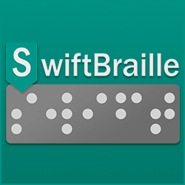
SwiftBraille is a soft keyboard customized for blind and visually impaired, allowing users to type using Braille language on touch screen devices. It works by connecting Braille dots together using at least one finger to connect or tap over Braille dots. This app features three layouts of braille dots, voice input, high customisation of keyboard size, colour, and position, and the ability to export generated text to external communication devices.
Compatibility: Requires Android 4.1 and up
Prices: Free.
More information at: SwiftBraille Web Page.
You can download this application from the Google Play Store.

