

**Message Dictation Apps**

Dictation apps allow individuals with cognitive, physical, or vision impairments to transcribe text that can be sent as a message, email, or other written form of communication. This involves speaking into the microphone while the app converts the speech into to text, which can then be directly sent using a communication app such as message, e-mail, Twitter, Facebook and so on.

The accuracy of the speech-to-text translation will vary between apps and across mobile device types and some apps will allow you to directly share your text with external apps while others may require you to copy and paste the transcribed text. Please contact your mobile provider or the application developer for more information.

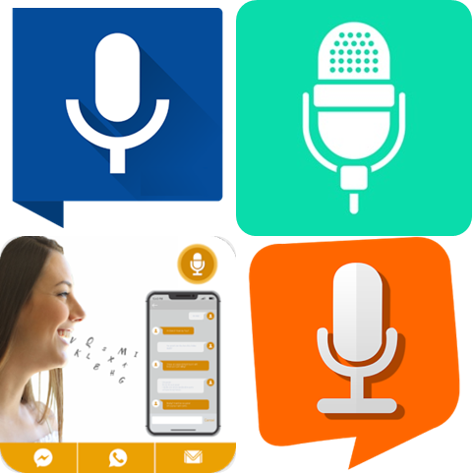

**Type of accessory: Application**

**Access Needs:**

* Cognitive
* Vision
* Physical

**Compatibility:**

* Each application will require a different operating system, which will affect the accuracy of the dictation service.

**Applications:**

1. **Voice Texting Pro**



The Voice Texting Deluxe works by converting your speech into text. You can then directly send the transcribed message to e-mail, SMS, Twitter, or Facebook or send it to your clipboard (copy) and paste the dictated text in any other application

Compatibility: Requires iOS 9.1 or later.

Prices: Free.

More information at: [Voice Texting Pro Web Page](http://www.sparklingapps.com/voicetextingpro/).

You can download this application from the [Apple App Store](https://apps.apple.com/au/app/voice-texting-pro/id542300792).

1. **SpeechTexter**

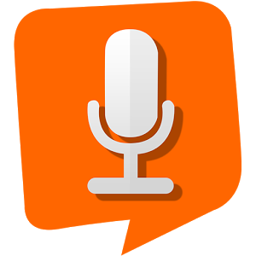

SpeechTexter is a voice to text app that provides continuous speech recognition designed to help create long and short bodies of text, including text notes, SMS, emails, and tweets.

Key features include a custom dictionary (punctuation marks, phone numbers, addresses, etc.), more than 60 languages and 95% accuracy for the English language.

Compatibility: Requires Android 4.4 and up.

Prices: Free

More information at: [SpeechTexter Web Page](https://www.speechtexter.com/).

You can download this application from the [Google Play Store](https://play.google.com/store/apps/details?id=com.speechtexter.speechtexter&hl=en_AU).

1. **Write Message by Voice**

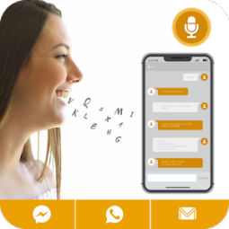

Write Message by Voice is a customisable app that lets you send written messages by transcribing your voice, without physically using the mobile device. This app does not require internet connection to work accurately, and voiced text can be directly shared to any communication app.

Compatibility: Requires Android 4.1 and up.

Prices: Free

More information at: [Write Message by Voice App Review Web Page](https://www.apkmonk.com/app/com.write.message.by.voice.sms.by.voice/).

You can download this application from the [Google Play Store](https://play.google.com/store/apps/details?id=com.write.message.by.voice.sms.by.voice&hl=en).

1. **Write SMS by Voice**

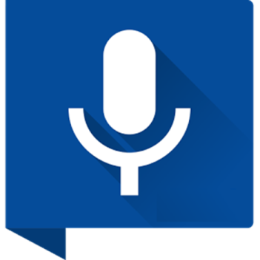

The Write SMS by Voice app allows you to dictate voice messages which will be translated, allowing you to send the resulting text via any other app or messenger.

Compatibility: Requires Android 4.4 and up.

Prices: Free

You can download this application from the [Google Play Store](https://play.google.com/store/apps/details?id=ru.vsms).

1. **Active Voice!**

Image of Active Voice! app Icon


Active Voice allows you to use your voice to send messages and emails. Its key features include direct sharing to messenger and email, easy to copy, translation into 32 languages, and offers American and British English.

Compatibility: Requires iOS 9.0 or later.

Prices: $9.99 as at 10/07/2019

You can download this application from the [Apple App Store](https://apps.apple.com/au/app/active-voice/id514916029).