Button Switch – Programmable or Smart
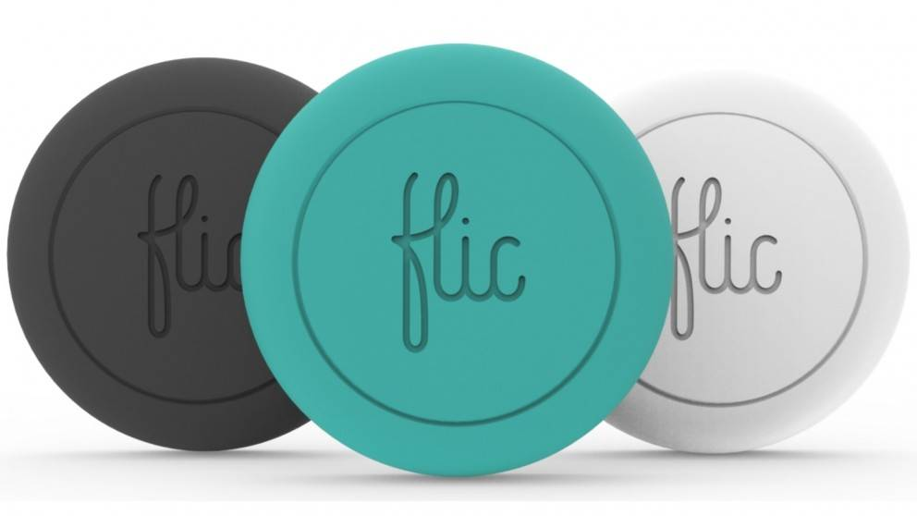
A programmable or a smart button is a physical button that can be programmed to complete an action or task of your phone when you press on it. They connect to your device via Bluetooth and tasks or actions can be set using an application on your device.

Type of accessory: Smart button

How do you use these accessories?
These accessories work by connecting to your android or apple device through Bluetooth. You then download an application on your device that lets you set functions or tasks that corresponds to you pressing the button. For example, the button can be pressed to ping your phone so you can find it, to send a message or to call a taxi or Uber to come and get you.

These accessories connect to phones via:
Audio Jack: No
Bluetooth: Yes
Wi-Fi: No
Micro USB: No
Other: No

Is there any other piece of equipment required for this accessory to work properly with a phone?
This accessory works using an app that can be downloaded from the Apple App Store or the Google Play Store

Programmable or Smart Button Switches – available in Australia:

Flic – Smart Bluetooth Button
The Flic Smart Bluetooth Button works with your phone or tablet device, as well as selected home automation products, to allow you to complete actions or tasks by clicking the button. The Flic has three trigger options, meaning you can set a different task for pressing the button, double-pressing the button, and holding the button.
This accessory works by downloading the Flic app from the Apple App Store or the Google Play Store. It allows you to connect several Flic buttons which can be attached to walls, tabletops, or other areas of your house or workplace.
In regards to communications, you can use this button to send a pre-set text messages or SMS as you push the button.
More information at:
Flic Button Web Page
List of Flic Functions
Flic Button Independent Living Centre Web Page
You can buy this accessory from Harvey Norman.

Is there any training available for these accessories?
  - Training and demonstrations might be available directly from retailers.
  - Some of these accessories might be displayed and available for demonstrations at Independent Living Centre Australia. Please contact ILC for further information.

