Phone Adaptors for Hearing Aids
Phone Adaptors for hearing aids are accessories that connect to landline or mobile devices and stream the sound wirelessly to the hearing aid. These devices allow individuals to stream conversations from phone calls directly from your mobile device or landline phone to your hearing aid, allowing for hands-free communication, and to be able to hear with both ears if you wear two compatible hearing aids.
Each one is designed only for mobile or only for landline.
Each of these accessories require apply only to specific models of hearing aids of the same brand e.g. the Oticon ConnectLine Streamer Pro can only be used by some Oticon hearing aids.
Please contact your hearing aid and service providers for more information on the compatibility with your device.
Type of accessory: Hearing Aid Accessory
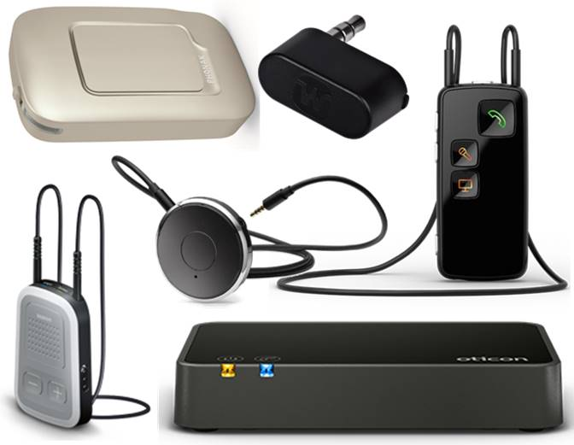

How do you use these accessories?
Pair these accessories to your hearing aid and connect it to your landline or mobile device. Some will connect to your device via Bluetooth, Wi-Fi, or through a port.

These accessories connect to phones via:
Audio Jack: Yes
Bluetooth: Yes
Wi-Fi: Yes
Micro USB: No
Other: No

Is there any other piece of equipment required for this accessory to work properly with a phone?
Yes, these accessories require a compatible hearing aid or implant. Please contact your provider for more information.

Mobile Phone Adaptors:

Bernafon SoundGate 3
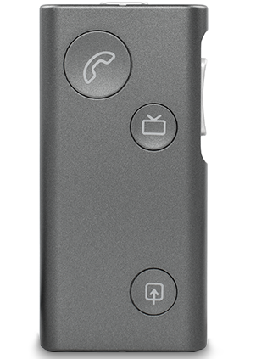
The Bernafon Soundgate 3 is a Bluetooth streamer and remote control that pairs to Bluetooth-enabled devices (e.g. mobile phones, music players) to stream sound directly from these devices to the hearing aids. The SoundGate 3 can also be used as a remote control for your hearing aids, allowing you to implement volume or program changes using the Bernafon SoundGate App on your iPhone or Android device.
SoundGate 3 features up to 60 hours battery life on standby, up to 10 hours for Bluetooth streaming when neck strap is used, or up to 5 hours Bluetooth streaming without the neck strap.
Compatibility: This accessory is compatible with all Bernafon wireless hearing aids and both Android and Apple devices. The Bernafon SoundGate App requires iOS 7.0 or later or Android 2.3.3 and up.
More Information at:
Bernafon Product Accessories Web Page
Bernafon SoundGate 3 User Manual (PDF Download)
Bernafon Wireless Connectivity Manual (PDF Download)
You can buy this accessory online at Value Hearing.

Oticon ConnectLine Streamer Pro
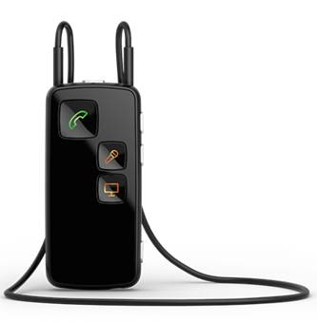
The Oticon Streamer Pro is intended to be used by wireless Oticon hearing aids users, connecting devices such as mobile phones with hearing instruments. The Streamer can be connected to a range of devices to enable you to communicate through your hearing aids by connecting with Bluetooth-enabled mobile phones. Your hearing aids become like wireless headphones, with the Streamer offering a microphone.
The Streamer is worn around the neck and features three dedicated buttons for the core applications: phone, TV and microphone. It can also be used as a remote control that enables you to adjust the hearing instrument volume and change programs in the hearing instruments.
Compatibility: This accessory is compatible with all Oticon hearing aids, and Apple iPhone devices that are later than the iPhone 4 and operating iOS 7 or above.
More Information at:
Oticon ConnectLine Web Page
Oticon ConnectLine Streamer Pro User Manual (PDF Download)
You can buy this accessory at an Oticon Hearing Centre, or online at Hearing Savers and The Hearing Care Shop.

Phonak ComPilot II
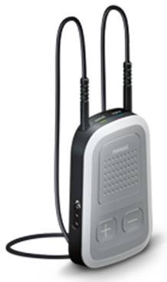
The Phonak ComPilot II connects Phonak hearing aids wirelessly, and via Bluetooth to a variety of audio sources, including cell phones, MP3 players, tablets, laptops and computers. The Phonak ComPilot connects all Phonak wireless hearing aids wirelessly to Bluetooth®-enabled phones and devices for speech or stereo music.
The ComPilot II can be used as a basic remote control to adjust the volume or program settings for you hearing aids, along with the Phonak RemoteControl app for more advanced control. It features up to 24-hours of streaming time in stereo sound.
Compatibility: This accessory is designed for the Phonak Audeo and Bolero Hearing Aids but is compatible with all Phonak wireless hearing aids. It is compatible with both Apple and Android mobile devices.
More Information at:
Phonak ComPilot II Web Page
Phonak ComPilot User Guide (PDF Download)
Phonak Wireless Connectivity Pamphlet (PDF Download)
You can buy this accessory online at Hearing Direct, Hear for Less, and Hearing Savers.

Phonak ComPilot Air II
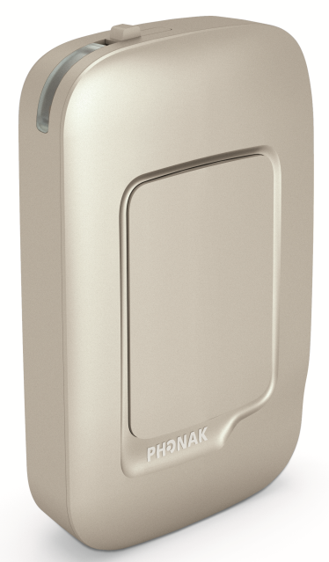
The Phonak ComPilot Air II is a wireless version of the ComPilot II designed to receive audio inputs from different Bluetooth devices and to transmit them wirelessly to your hearing aids. During a phone call, the ComPilot Air operates as the microphone while your hearing aids become wireless headphones.
The ComPilot Air II can be used as a basic remote control to adjust the volume or program settings for you hearing aids, along with the Phonak RemoteControl app for more advanced control. It features up to 24-hours of streaming time in stereo sound.
Compatibility: This accessory is designed for the Phonak Audeo and Bolero Hearing Aids, however please check compatibility with your Phonak hearing aids and note that ComPilot Air II is not compatible with the older Phonak Quest, Spice or Core wireless hearing aids. It is compatible with both Apple and Android mobile devices.
More Information at:
Phonak ComPilot Air II Web Page
Phonak ComPilot Air II User Guide (PDF Download)
Phonak Wireless Connectivity Pamphlet (PDF Download)
You can buy this accessory online at Hearing Direct and Hearing Savers

Siemens Signia easyTek
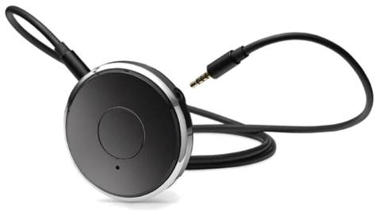
The Siemens Signia easyTek allows users to transform wireless hearing aids into stereo headsets, with multi-function buttons that allow you to turn easyTek on and off, answer a phone call, control volume, change listening programs, or switch audio sources. Combined with the easyTek App for Android and Apple, this accessory lets you control your hearing aid from your phone and engage in hands-free conversations.
Compatibility: easyTek is compatible with any Siemens Signia wireless hearing aid and works with most Bluetooth-enabled mobile devices. Please note this streamer needs to be paired with your hearing aids at a clinic.
More information at:
Signia Accessories Web Page
Signia easyTek User Guide (Download)
Signia easyTek 'Handle Phone Calls' Video (YouTube)
You can buy this accessory online at Hearing Savers and the Hearing Care Shop.

Unitron uDirect 3
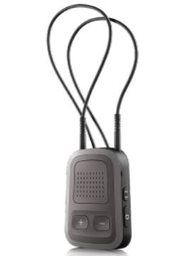
The Unitron uDirect 3 is a streaming accessory that is compatible with any Bluetooth-enabled mobile device to stream phone conversations wirelessly to your hearing aids. It allows you to hear the caller’s voice directly in your hearing aids and picks up your voice through the uDirect 3 microphone and streams it to your phone.
The uDirect 3 includes a neck loop which offers to most direct pairing and unobstructed microphone access.
Compatibility: The uDirect 3 is compatible with Wireless Hearing Aids using the Tempus and North Platforms, and works with most Bluetooth-enabled mobile devices.
More information at:
Unitron Product Web Page
Unitron uDirect 3 Pairing Instructions (Download)
Unitron Pairing uDirect with Phone Video
You can buy this accessory online at Hearing Savers and Hear for Less.

Widex CALL-DEX
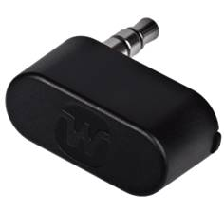
The Widex CALL-DEX is a mobile phone streaming accessory that inserts into the jack plug of your mobile device, allowing you to stream conversations directly from your mobile phone to your hearing aids. The mobile device with the CALL-DEX attached is used as the microphone while the hearing aids become wireless headphones.
The CALL-DEX can stream for up to 80 hours, uses the same battery as a hearing aid, and must be in range of your hearing aids to work.
Compatibility: The CALL-DEX is compatible with the Widex DREAM and UNIQUE hearing aid family, and works with most mobile devices that have a jack port.
More information at:
Widex CALL-DEX Web Page
Widex CALL-DEX User Manual (PDF Download)
You can buy this accessory online at Value Hearing, Smart Hearing Solutions, The Hearing Care Shop and Hearing Savers.

Landline Phone Adaptors:

Bernafon Phone Adaptor 2 – Requires SoundGate 3
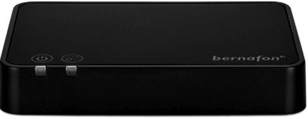
The Bernafon Phone Adaptor 2 is a landline phone streaming device that can be plugged into any landline phone in order to stream the sound signal directly to the hearing aids, via the SoundGate 3. The SoundGate 3 must be connected wirelessly to the hearing aids and phone Adaptor to be able to make and receive phone calls from the landline device.
Compatibility: This accessory is compatible with all Benaforn Saphira and Juna hearing aids and most landline devices.
More Information at:
Bernafon Phone Adaptor 2 User Manual (Download)
Bernafon Wireless Connectivity Manual (Download)
You can buy this accessory online from Value Hearing.

Oticon ConnectLine Phone Adaptor 2.0 – Requires Oticon ConnectLine Streamer Pro or ConnectClip
The Oticon ConnectLine Phone Adaptor allows individuals with hearing aids to control incoming and outgoing landline phone calls. The phone Adaptor is connected to a power outlet and landline device, and is then paired with the Oticon Streamer Pro. Using the Streamer Pro as a microphone and your hearing aids as a headset, you are able to answer, hear, and engage in phone conversations hands-free.
Compatibility: This accessory is compatible with all Oticon hearing aids and most landline devices.
More Information at:
Oticon ConnectLine Web Page
Oticon ConnectLine Instructions Web Page (Includes Videos)
You can buy this accessory at an Oticon Hearing Centre, or online at Hearing Savers, Ear and Hearing, and Value Hearing.

Is there any training available for these accessories?
Training and demonstrations might be available directly from hearing aid retailers and audiology clinics.

