Touch Screen Stylus - Pens
Stylus pens are devices designed to interact with the touch screen of your device in the same way as your fingers do, but allowing greater precision. Standard Stylus pens allow users to “write” on the touch screen as if they are writing on paper, allowing for input of handwriting, drawings, and other gestures.
There are many variations of the Stylus pen available, with many being adapted to allow people with different mobility impairments to access their devices. They are also useful for people with vision impairment or who are blind that know or remember how to handwrite as they can write emails and text messages without the use of a keyboard.
Type of accessory: Prosthetic accessories
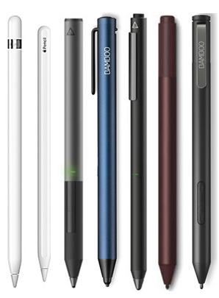

How do you use these accessories?
Simply place the tip of the stylus to the screen to select, write and draw among other functions.
Accessories will vary in shape, size, and required pressure to suit your mobility needs and control.

These accessories connect to phones via:
Audio Jack: No
Bluetooth: No
Wi-Fi: No
Micro USB: No
Other: No

Is there any other piece of equipment required for this accessory to work properly with a phone or tablet?
No, if the material used for the tip of the stylus is compatible with the touch screen of your device then you should not need anything else.

Compatibility:
Styluses are designed to work with specific types of touchscreens. Please check compatibility with your supplier before purchasing.

Touch Screen Stylus Pens available:
There are many options for Standard Stylus pens on the market. These take the shape of a standard pen and allow for more control of your touch screen device. They can be of benefit for individuals who struggle to control their smart device using their finger.
Below is a limited list of available stylus pens and their compatibility. Each stylus is compatible with certain tablet or mobile devices. Please check with supplier for the compatibility with your device.

Apple Pencil (1st Generation)
The Apple Pencil connects to your device through Bluetooth, allowing you to draw, write, sketch, and mark-up on iPad devices.
Compatibility: Designed to work with the iPad Air (3rd generation), iPad mini (5th generation), 10.5-inch iPad Pro, iPad (6th Generation), iPad Pro 12.9-inch (2nd Generation), iPad Pro 12.9-inch (1st Generation), and iPad Pro 9.7-inch.
You can buy this accessory online from the Apple Store, JB Hi-Fi, Officeworks, Harvey Norman and Target.

Apple Pencil (2nd Generation)
The 2nd generation Apple Pencil connects to your device through Bluetooth.
Compatibility: Designed to work with the 11-inch iPad Pro and the 12.9-inch iPad Pro (3rd generation).
You can buy this accessory online from the Apple Store, JB Hi-Fi, Officeworks, Harvey Norman and Target.

Adonit Pixel Stylus
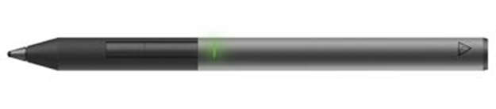
Adonit Pixel will work just like your finger on any capacitive touch screen device; however additional features will require an iOS device with Bluetooth 4.0.
Compatibility: Designed to work with the iPhone 4, 4s, 5, 5c, 5s, 6, 6 Plus, 6s, 6s Plus, SE, 8, 8 Plus, X, Xs, Xr, iPad Mini, iPad Mini 2, iPad Mini 3, iPad Mini 4, iPad Air, iPad Air 2, iPad 2017 (5th generation).
More information at: Adonit Pixel Web Page and Adonit Pixel Support Page
You can buy this accessory online from the JB Hi-Fi and Officeworks.

Wacom Bamboo Tip
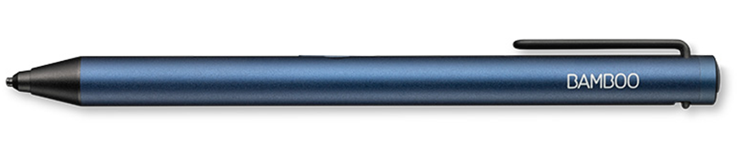
Bamboo Tip is a fine-tip stylus for quickly noting ideas on your iPhone, iPad and Android devices.
Compatibility: Designed for Apple iOS and Android touch screen devices. Please see Wacom Bamboo Compatibility Web Page for specific devices.
More information at: Wacom Bamboo Tip Web Page
You can buy this accessory online from Wacom Australia, JB Hi-Fi, Harvey Norman and Officeworks.

Adonit Dash 3 Stylus
Compatibility: Designed to work with the iPad 4, all iPad Minis, all iPad Airs, iPad 2017, and iPhone 5 and newer, and most Android touch screen devices.
More information at: Adonit Dash 3 Web Page and Adonit Dash 3 Support Page.
You can buy this accessory online from JB Hi-Fi and Officeworks.

Surface Pen
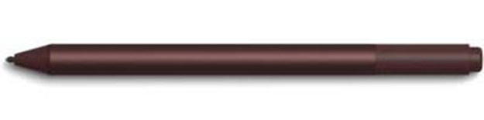
Compatibility: Designed to work with the Surface Book & 2, Surface Studio, and Surface Studio 2, Surface Laptop 1st Gen, Surface Laptop 2, Surface Go, Surface Pro 3, Surface Pro 4, Surface Pro 5th Gen, Surface Pro 6, and Surface 3.
More information at: Microsoft Surface Pen Web Page.
You can buy this accessory online from JB Hi-Fi, Harvey Norman, Kogan, The Good Guys and Dick Smith.

Wacom Bamboo Ink
Bamboo Tip is a fine-tip stylus for quickly noting ideas on Windows 10 devices.
Compatibility: Designed for Windows 10 devices. Please see Wacom Bamboo Compatibility Web Page for specific devices.
More information at: Wacom Bamboo Ink Web Page
You can buy this accessory online from Wacom Australia, JB Hi-Fi, Harvey Norman and Officeworks.

