Headset Adaptors/Amplifiers for Landlines
Most landline phones are unable to connect directly to headsets or headphones. These accessories are designed to provide that connection together with amplification. These devices can connect corded and cordless phones to corded and Bluetooth headsets and headphones to allow hands-free communication in the office or at home. While some cordless landlines now have built-in Bluetooth functions, corded landlines may require additional Adaptors to connect to headsets.
These accessories are designed for specific headsets and compatibility will depend on the landline model. Please contact your company IT department and headset provider for further information on compatibility

Type of accessory: Headset Adaptor and amplifier
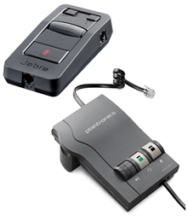

How do you use these accessories?
The landline Adaptor is connected to the base of the desk phone. Then, depending on the model, it is either connected using a cord or via Bluetooth to your headsets. Many models allow you to answer/decline calls, control volume, and adjust settings of your landline call and headsets using controls on the Adaptor.
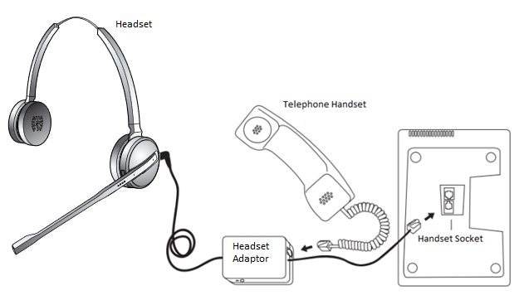

These accessories connect to phones via:
Audio Jack: Yes
Bluetooth: Yes
Wi-Fi: No
Micro USB: No
Other: Yes – Standard Telephone handset socket

Is there any other piece of equipment required for this accessory to work properly with a phone?
These accessories act as a bridge between landline devices and headsets. Outside of this, no additional equipment should be required.

Compatibility:
Compatibility of these accessories will depend on the make and model of the landline device and the required connectivity (cord or Bluetooth) to your headsets.

Headset Adaptors for Landlines available in Australia:

Plantronics Vista M22
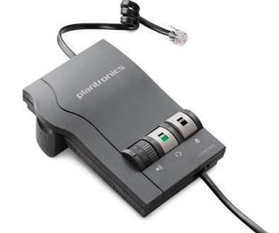

Plantronics M22 amplifier provides compatibility with telephones that do not allow direct connection to headsets, while amplifying and enhancing the sound-quality of phone conversations. Plantronics SoundGuard Plus technology ensures loud tones are quickly reduced to more comfortable levels and ensures that the normal, human voice remains natural and unchanged, for face-to-face clarity of communication.
The Vista M22 is designed to connect corded headsets with desk phones, allowing for additional call control including volume control and headset/handset select
More information at: Plantronics Vista M22 Web Page, Plantronics Vista M22 Product Sheet (PDF Download) and the Plantronics Vista M22 User Manual.
You can buy this accessory from Office Life.

Jabra Link 850
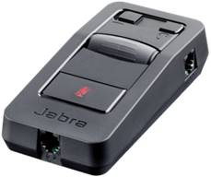
The Jabra Link 850 is a headset amplifier, and it allows you to simultaneously connect to computers via USB and desktop phones to a headset. It works to reduce external noises and remove line disruptions, while also allowing you to connect existing headsets to landline phones.
The Jabra Link 850 is designed to work with majority of desk phones and all Jabra headsets.
More information at: Jabra Link 850 Web Page and the Jabra Link 850 manuals.
You can buy this accessory from Headsets Online, Simply Headsets, and Jabra.

Is there any training available for these accessories?
Training and demonstrations may be available directly from retailers.

