Bluetooth Hearing NeckLoop
A Bluetooth Hearing Loop allows deaf persons and people with hearing disabilities to wirelessly transmit calls and music to a hearing aid with built-in telecoil, allowing them to control their phone or tablet hands-free. It connects to a smartphone or tablet via Bluetooth.
Type of accessory: Hearing NeckLoop

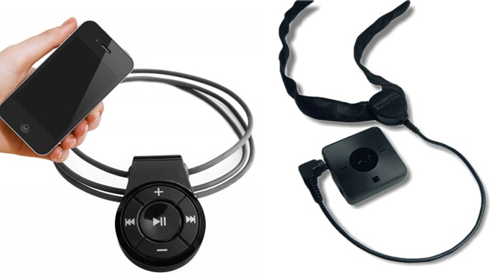

How do you use these accessories?
Pair this accessory to your mobile phone or tablet via Bluetooth. Use the buttons on the device to answer, reject and end calls, adjust the volume and stream music to remotely control your smartphone or tablet.

These accessories connect to phones via:
Audio Jack: No
Bluetooth: Yes
Wi-Fi: No
Micro USB: No
Other: No

Is there any other piece of equipment required for this accessory to work properly with a phone?
Yes, your hearing device (hearing aid, cochlear implant, BAHA etc) requires a telecoil (also called a T-Switch).

Compatibility:
The hearing loop is compatible with Bluetooth enabled devices and hearing aids with a built-in telecoil.

Popular Hearing Loops available in Australia:

Artone 3 MAX Bluetooth Loopset
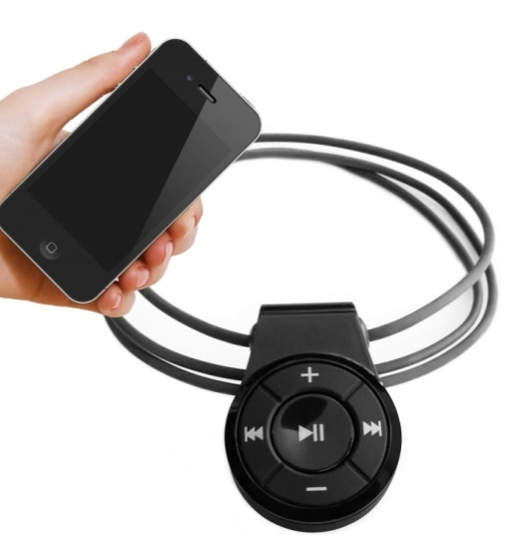
The Artone 3 MAX Bluetooth Loopset is a wireless listening assistive device with built-in Bluetooth technology. It allows hearing aid users to listen to amplified and noise free cell phone conversation and enjoy stereo music streamed from Bluetooth-enabled cellular phones, personal computers or tablets.
This accessory allows hearing aid and cochlear implant users to answer and participate in a call without opening their mobile device. It features a play/pause button which can be used to answer a call, as well as volume control buttons and skip/repeat buttons.

More information at:
Hearing Connect Product Web Page
Artone 3 MAX Bluetooth Loopset User Manual (Download)

You can buy this accessory online by contacting Hearing Connections and from Clearasound.

AB Transistor Transett T-Bluetooth Hearing Loop
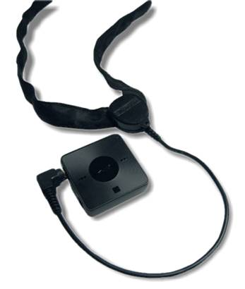
The Transett T-bluetooth allows hearing aid users to communicate with mobile phone by wireless audio transmission to the hearing aid via the supplied neck loop.
Features
- Answer, end and reject calls
- Built-in microphone
- Can also be used with headphones for those who do not have a hearing aid
- Connects to two Bluetooth devices at the same time
- Easy pairing to a NFC enabled smartphone or tablet
- Includes AC charger and USB cable for charging
- Includes Sony SBH20 Stereo Bluetooth Handset
- LED lights to indicate battery life, incoming call and connectivity
- Play, pause and skip tracks
- Raised icon controls for easy use without looking
- Reduces background noise for optimum hearing
- Rotating clip to attach accessory onto neck loop or clothing at preferred angle
- Two-channel neck loop with 70cm extension cable
- Volume control

More Information at:
AB Transistor Transett T-Bluetooth Hearing Loop Web Page
AB Transistor Transett T-Bluetooth Hearing Loop PDF Brochure (Download)
You can buy this accessory online at PhoenixHearing.
Training and demonstrations might be available directly from PhoenixHearing.

