Roger Hearing Accessories
Phonak Roger Hearing devices allow people with hearing loss to listen and speak on their Bluetooth capable device.
In addition, if the user has two hearing aids and/or cochlear implants, the user can use the accessories to hear the phone with both ears.
Type of accessory: Assistive Listening Devices
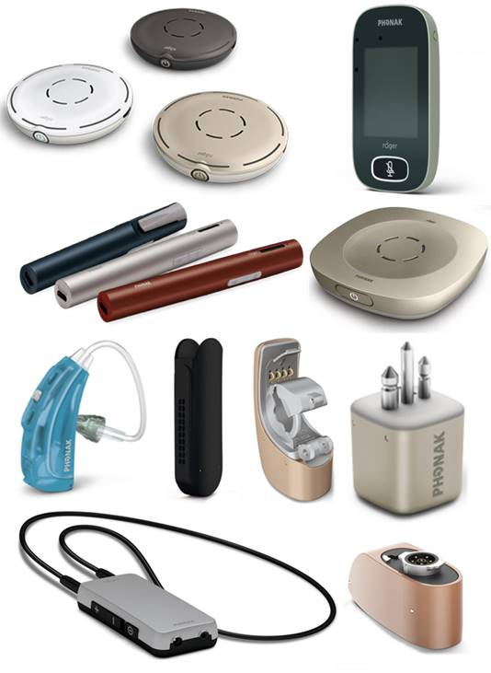

How do you use these accessories?
Press the answer button on the microphone to answer a call, and wear the receiver with your hearing aid (or headphones or earbuds). Speak into the microphone, and adjust the volume on your hearing aids and/or cochlear implants, or the MyLink receiver.
An example of how to use these devices can be seen at: PhonakPro Pen Support Video
Additionally, Phonak’s Roger Configurator is an interactive tool that provides advice on the receiver and transmitter needed for your hearing aid.

These accessories connect to phones via:
Audio Jack: No
Bluetooth: Yes
Wi-Fi: No
Micro USB: No
Other: No

Is there any other piece of equipment required for this accessory to work properly with a phone?
Yes – used with a compatible Roger receiver.

Compatibility:
Any Bluetooth device

Roger Hearing Devices available in Australia:

Transmitters:
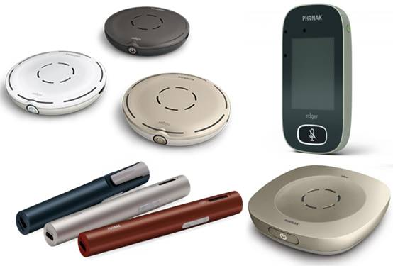

Roger Pen
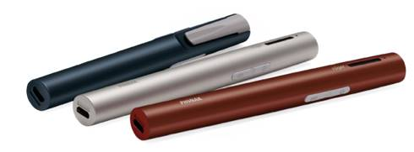
The Roger Pen is a wireless, portable microphone which helps people with a hearing loss by offering additional support in understanding speech over distance or in noisy environments. It uses Bluetooth to wirelessly connect to mobile devices and transmits the speaker’s voice to the hearing aid for greatly improved conversation quality and hands-free calls.
It can also stream sound from TVs, music players, computers, and more by connecting to the included charging dock or the micro-USB socket on the Roger Pen. The Roger Pen is used with miniature Roger receivers, which can be attached directly to hearing aids or cochlear implants, and is compatible with the Roger X, Roger design-integrated receivers, and the Roger MyLink receivers.
More information at:
Roger Pen PhonakPro Web Page
Roger Pen PhonakPro Support Web Page
Roger Pen User Guide (Download)
Roger Receiver Compatibility Information (Download)
You can buy this accessory online at Hearing Connections, Hearing Savers, Word of Mouth Technology, eardeals.com.au, and Ear & Hearing.

Roger Select
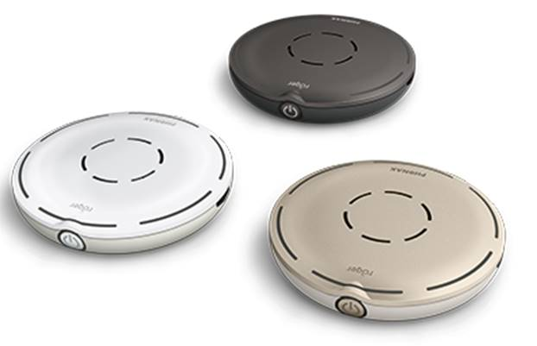
The Roger Select is a device utilizing multiple microphones and designed for stationary situations with multiple speakers. It automatically selects the person who is talking and switches from one talker to another when required, helping people with hearing impairments to follow the conversation without having to adjust the microphone.
It uses Bluetooth to wirelessly connect to mobile devices and transmits the speaker’s voice to the hearing aid for greatly improved conversation quality and hands-free calls. It can also stream sound from TVs, music players, computers, and more by connecting to the included charging dock or the micro-USB socket on the Roger Select. The Roger select is used with miniature Roger receivers, which can be attached directly to hearing aids or cochlear implants, and is compatible with the Roger X, Roger design-integrated receivers, and the Roger MyLink receivers.
More information at:
Roger Select PhonakPro Web Page
Roger Select PhonakPro Support Web Page (Including How To Videos)
Roger Select User Guide (Download)
You can buy this accessory online at Hearing Connections, Hearing Savers, Word of Mouth Technology, and eardeals.com.au.

Roger Table Microphone II
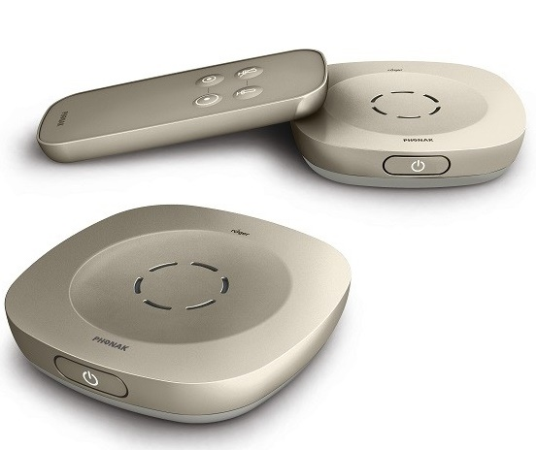
The Roger Table Mic II is a wireless microphone design for people with a mild and mild-to-moderate hearing loss who participate in various meetings and similar situations. It selects the person who is talking and switches automatically between meeting participants. The Roger Table Mic II can be connected to other Table Mics or any of the microphones in the Roger for adult portfolio to give full coverage of large meetings or conversations with many participants.
Connecting to a range of compatible Roger receivers, the Roger Table Mic II distinguishes the spoken work and transmits speech to the hearing aids from wherever the conversation takes place. The Table Mic II is used with miniature Roger receivers, which can be attached directly to hearing aids or cochlear implants, and is compatible with the Roger X, Roger design-integrated receivers, and the Roger MyLink receivers.
More information at:
Roger Table Microphone II PhonakPro Web Page
Roger Table Microphone II PhonakPro Support Web Page (Including How To Videos)
Roger Table Microphone II User Guide (Download)
You can buy this accessory online at Hearing Connections, Hearing Savers, Word of Mouth Technology, and eardeals.com.au.

Roger Touchscreen Microphone
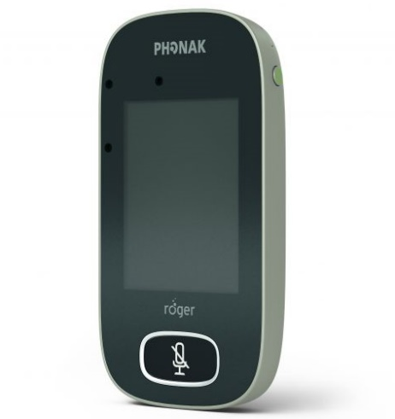
The Roger Touchscreen Mic is a wireless microphone accessory designed for use in school classrooms to ensure students with hearing impairments can participate in class communication fully. It features an automatic microphone function which conveniently switches from an individual talker to a small group interaction mode, based on the orientation of the device.
The microphone features two buttons, which power on/off and mute the device, and 12 touchscreen functions allowing for control of connected devices, device listening style, and volume and microphone modes. It also uses Bluetooth to connect with other classroom devices.
The device is used in a classroom or similar environment in which the teacher wears the device, controlling the settings between individual or small group interaction modes, and the sound is transmitted to the students hearing instrument. The Roger Touchscreen Mic is compatible with almost every hearing instrument, cochlear implant and bone-anchored hearing device, allowing multiple receivers and microphones to be connected in a network with simple touch commands.
More information at:
Roger Touchscreen Mic PhonakPro Web Page
Roger Touchscreen Mic PhonakPro Support Web Page
Roger Touchscreen Mic User Guide (Download)
You can buy this accessory online at Hearing Connections, and Word of Mouth Technology.

Receivers:
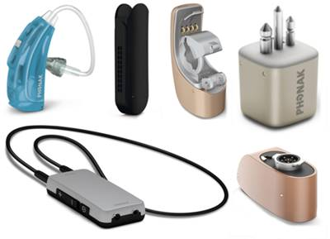
Roger Receivers are used to transmit the signal from a Roger microphone directly to your hearing aid or cochlear implant sound processor. There are several categories and varieties available, therefore it is recommended you consult your health professional or hearing aid provider for the most suitable receiver and transmitters.

Roger MyLink
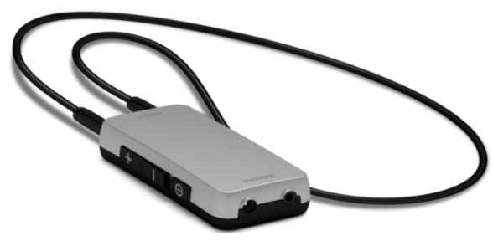
The Roger MyLink is a universal neck loop receiver that connects with a variety of Roger microphones to transmit speech, allowing for improved communication for people with hearing impairments. It is compatible with any hearing aid or cochlear implant that has a Telecoil (also called a T-Switch), and can be used by people who do not wear a hearing aid through the use of headphones or earbuds.
The MyLink has a rechargeable built-in battery that will last over 10 hours of operating time. It features a 2.5 mm headphone socket, detachable 760mm and 560mm neck loops, and a LED light which indicates battery level, charging status, and volume control.
More information at:
Roger Receivers Phonak Web Page
Roger MyLink Phonak User Guide (Download)
Roger MyLink Phonak Introduction Video (YouTube)
Roger Receivers Support Web Page
You can buy this accessory online at Hearing Connections, Hearing Savers, and Word of Mouth Technology.

Roger Focus
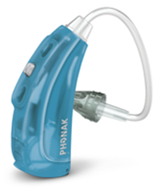
The Roger Focus receiver enables people with normal hearing and unilateral hearing loss to be more attentive by bringing speech directly to their ears and reducing the effects of distance, background noise, and reverberation. It is designed to help children with attention-related issues and hearing impairments focus and understand more in the class room environment.
The Roger Focus is compatible with all Roger microphones and is designed to not interfere with systems running on 2.4 GHz so it can easily be used alongside other types of technology. It features volume control buttons, water, sweat and dust resistant technology, and requires minimal programming.
More information at:
Roger Receivers Phonak Web Page
Roger Focus Phonak Web Page
Roger Focus Support Web Page
Roger Focus Informational Brochure (Download)
You can buy this accessory online at Hearing Connections and Word of Mouth Technology.

Roger X
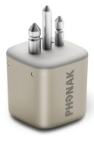
The Roger X Receiver is a small universal device that clips unobtrusively onto the base of your hearing aid or implant so it is ready to receive audio from a variety of Roger wireless microphones. This receiver is compatible with the majority of behind-the-ear hearing aids and cochlear implants, and functions when connected to an audio shoe or streamer.
More information at:
Roger Receivers Phonak Web Page
Roger X Phonak Data Sheet– including excluded compatibility (Download)
Roger Receivers Support Web Page
You can buy this accessory online at Hearing Connections, Hearing Savers, Hearing Direct, Word of Mouth Technology, and Ear and Hearing.

Roger 20
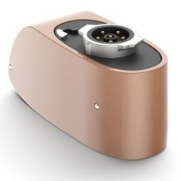
The Roger 20 is a receiver that is compatible with the Cochlear Nucleus 7 cochlear implant sound processor. Attaching the Roger 20 to the cochlear implant allows individuals to more clearly hear any speaker using a Roger wireless microphone. With a compact design, this receiver has demonstrated speech-in-noise performance allowing to improved communication for individuals with cochlear implants.
More information at:
Roger Receivers Phonak Web Page
Roger 20 Datasheet (Download)
You can buy this accessory online at Hearing Connections

Roger 21
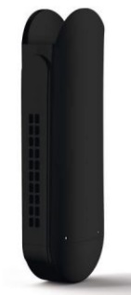
The Roger 21 is a receiver that is compatible with the MED-EL Sonnet cochlear implant audio processor. Attaching the Roger 21 to the Sonnet audio processor allows individuals to more clearly hear any speaker using a Roger wireless microphone. With a compact design, this receiver has demonstrated speech-in-noise performance allowing to improved communication for individuals with cochlear implants.
More information at:
Roger Receivers Phonak Web Page
Roger 21 Datasheet (Download)
You can buy this accessory online at Hearing Connections

How and where to get them from?
These accessories are available in a number of assistive technology retailers in Australia, such as Hearing Connections, Hearing Savers, Word of Mouth Technology, Ear Deals, and Ear & Hearing. Please consult your health care professional or specialist for additional resellers.

Is there any training available for these accessories?
Training is usually available from the place of purchase, and webinars on how to set up these accessories are available at PhonakPro.

