Smartwatches – Bluetooth and Cellular

A smartwatch is a watch that is able to host and activate some functions that are commonly found on smartphones, such as making and receiving calls and messages, scheduling events, providing directions, check the weather and many more functions. They usually have touchscreens and often record your heart rate and other vital signs.
Standalone smartwatches have a built-in cellular connectivity that allows then to make calls or send messages without having it connected to a smartphone.
Type of accessory: Standalone Smartwatch
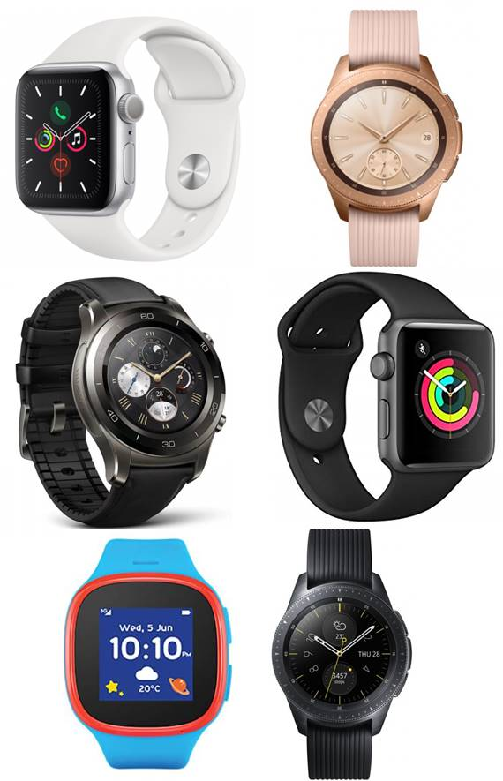
How do you use these accessories?
You can access the different functions and settings of your smartwatch by using their touchscreen, dials and buttons. Some brands allow you to speak commands to them.

Compatibility:
Apple smartwatches are currently only compatible with iPhones and iPads. While Smartwatches based on Google Wear operating system (former Android Wear OS) are compatible with Android phones from different brands, and they and can also have certain compatibility with Apple iPhones.
Please check compatibility with your retailer before purchasing any smartwatch.

Popular Standalone Smartwatches in Australia:

Apple Watch Series 5

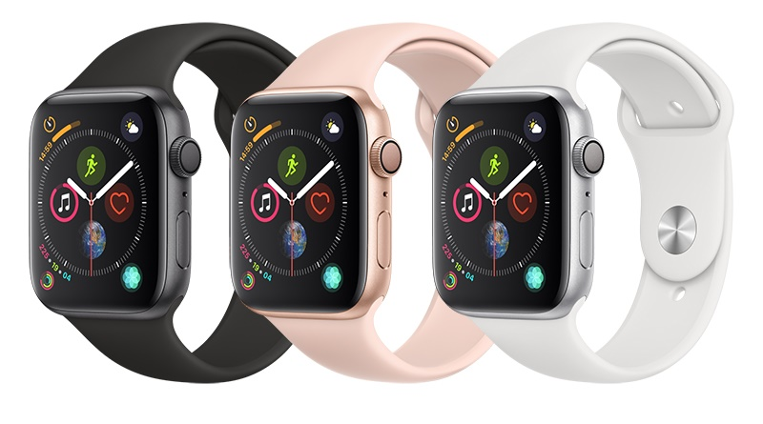
Features
- Activity Tracker
- Click speed adjustments
- Display Characteristics options - Grayscale, Negative colour, and High Contrast
- Enable direct access to accessibility settings
- Emergency call feature based on heart rate monitor and fall detection service
- GPS, Bluetooth, and Cellular capabilities
- Make calls from your wrist
- Messaging Options - Predictive text, MMS, IM, Email, and Text messaging/SMS
- Personal Assistant / Voice Control (Siri)
- Screen Magnifier
- SOS messages
- Speaker-phone capable
- Haptic Engine: Vibrating Alerts for incoming calls, messages or notifications
- Visual and Vibrating Alerts - Incoming calls, messages or notifications
- Voice Notes and reminders
- Water resistance to 50 meters
- Mono Audio – can adjust the balance for greater volume in either ear

You can buy this device on a plan from Vodafone and Optus. Also outright at Apple, JB Hi-Fi, Bing-Lee, Officeworks, Target, and Harvey Norman.

More information at:
Apple Watch Series 5 Web Page
Apple Watch Series 5 User Manual
Apple Watch Accessibility Web Page
Connecting to Cellular on Apple Watch Support Web Page
Apple Watch Emergency Call

Apple Watch Series 3
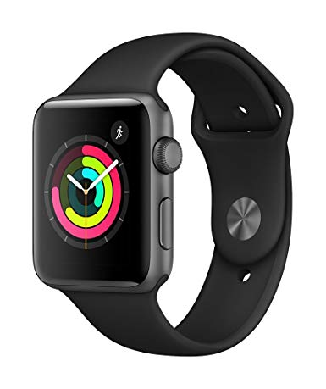

Features
- Activity Tracker
- Click speed adjustments
- Display Characteristics options - Grayscale, Negative colour, and High Contrast
- Enable direct access to accessibility settings
- GPS, Bluetooth, and Cellular capabilities
- Make calls from your wrist
- Messaging Options - Predictive text, MMS, IM, Email, and Text messaging/SMS
- Personal Assistant / Voice Control (Siri)
- Screen Magnifier
- SOS messages
- Speaker and microphone capable
- Haptic Engine: Vibrating Alerts for incoming calls, messages or notifications
- Visual and Vibrating Alerts - Incoming calls, messages or notifications
- Voice Notes and reminders
- Water resistance to 50 meters

You can buy this device from on a plan from Vodafone, Telstra and Optus. Also outright at Apple, JB Hi-Fi, The Good Guys, Bing Lee, Dick Smith, Target, and Harvey Norman.

More information at:
Apple Watch Series 3 Web Page
Apple Watch Accessibility Web Page

Samsung Galaxy Watch 4G
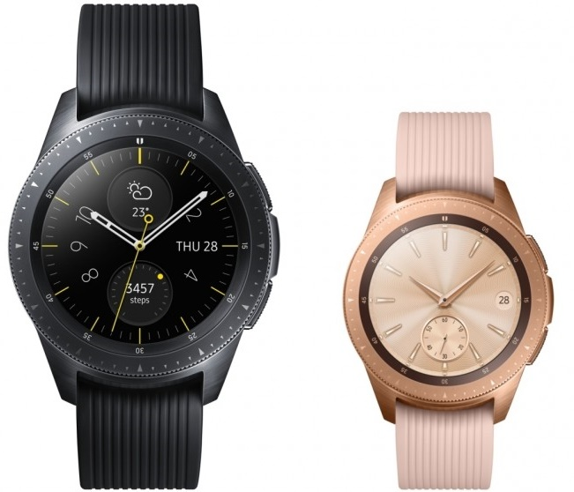
Features
- Activity Tracker
- Click speed adjustments
- Display Characteristics options – Adjustable brightness, screen timeout
- Enable direct access to accessibility settings
- GPS, Bluetooth, and Cellular capabilities
- Make calls from your wrist
- Messaging Options - Predictive text, MMS, IM, Email, and Text messaging/SMS
- Screen Magnifier
- SOS messages
- Speaker and microphone capable
- Text-to-speech setting - language, speech rate, notifications
- Touch sounds – Sound made when apps or options are selected
- Visual and Vibrating Alerts - Incoming calls, messages or notifications
- Voice Assistant
- Voice Notes and reminders
- Water and dust resistance

You can buy this device on a plan from Telstra, Vodafone and Optus. Also outright at JB Hi-Fi and Harvey Norman.

More information at:
Samsung Galaxy Watch Web Page
Samsung Galaxy Watch User Manual PDF
Connecting to Australian Telco Providers information Web Page

Huawei Watch 2 4G
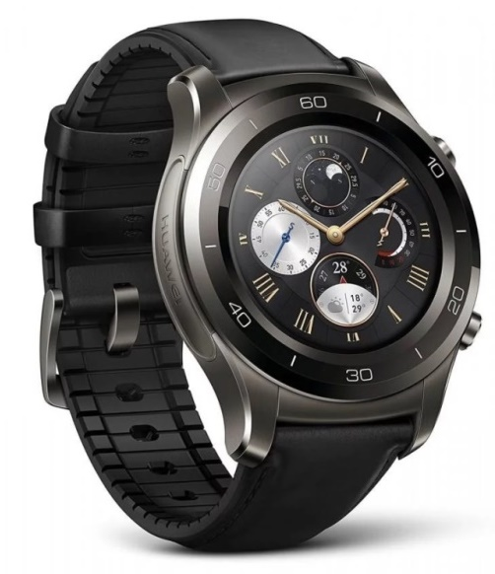

Features
- Activity Tracker
- Display Options - Adjustable Brightness Control and Font Size
- Google Assistant / Voice Control
- GPS, Bluetooth, and Cellular capabilities
- Make calls from your wrist
- Messaging Options
- Messaging Options - Predictive text, MMS, IM, Email, and Text messaging/SMS
- Reduce motion option
- Screen Magnifier
- Speaker and microphone capable
- TalkBack - screen reader and voiced menus
- Text-to-speech settings - change language, volume, and speaking speed
- Visual and Vibrating Alerts - Incoming calls, messages or notifications
- Voice Notes and reminders
- Water and Dust resistant

You can buy this device on a plan from Vodafone and outright at MobileCiti.

More information at:
Huawei Watch 2 Web Page
Huawei Watch 2 User Manual PDF

Alcatel Family Watch
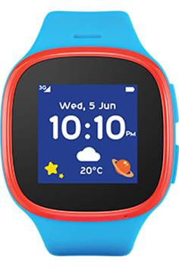

Features
- This watch is designed to allow parents to track their kids. It does not have text message capabilities, but it can make and receive calls from pre-approved phone numbers.
- Display Options - Adjustable Brightness Control and Font Size
- GPS, Bluetooth, and Cellular capabilities
- Make calls from your wrist
- Speaker and microphone capable
- Visual and Vibrating Alerts - Incoming calls, messages or notifications

You can buy this device outright or on a plan from Vodafone.

More information at:

Ausdroid review of Alcatel Family Watch

Alcatel Move Time (Family Watch) Website

