Hearing Aids for Android
Hearing aids for Android allow people with hearing loss or deafness to hear more clearly by streaming sound directly to the hearing aid. The hearing aids can be controlled directly from an Android smartphone or tablet via an app and connect via Bluetooth.

Type of accessory: Hearing aid
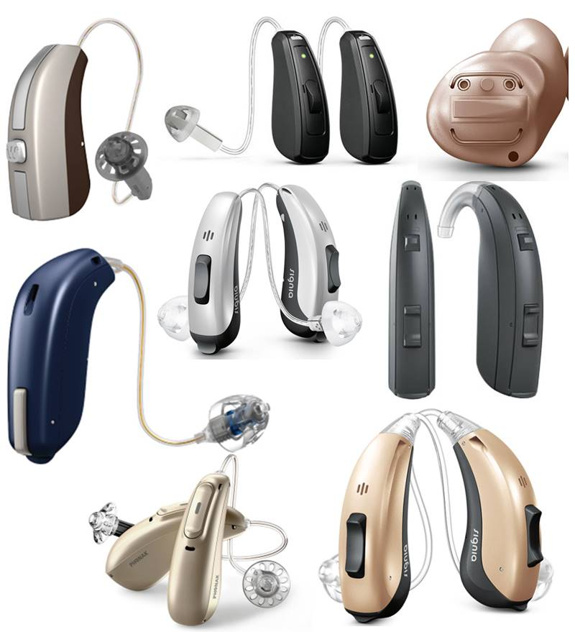

How do you use these accessories?
Pair your hearing aids to your Android device via Bluetooth and control them from your smartphone or tablet. Go to ‘Settings’ on your Android device, then select ‘Connections’ and then ‘Bluetooth’, select your hearing aid on the list of “Available Devices” to complete the pairing. Download the smartphone app for your hearing aid to adjust sound quality and use the features to tailor them to your individual needs.
How to pair your Android phone with your hearing aids. (Video)

These accessories connect to phones via:
Audio Jack: No
Bluetooth: Yes
Wi-Fi: No
Micro USB: No
Other: No

Is there any other piece of equipment required for this accessory to work properly with a phone?
Some hearing aids do not need additional accessories to connect to Android devices. Some other hearing aids will need an additional piece of equipment for this accessory to connect or work properly with a phone or tablet. This information is presented in the description of each hearing aid.

Compatibility:
Please check with your hearing aid supplier to confirm compatibility with the current version of your Android smartphone or tablet.

Popular hearing aids available in Australia:

Bernafon Zerena - Connects to Android devices by using an additional phone clip

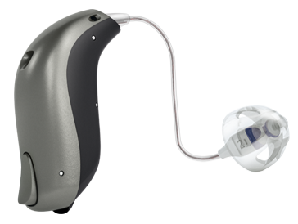
The Bernafon Zerena hearing aid improves speech understanding while reducing listening effort, continuously monitoring your listening environment. This hearing aid can be controlled using the EasyControl-A app to adjust volume, mute, change program, view battery life and find a misplaced hearing aid. This hearing aid requires Apple devices to be running iOS 9.3 or later.
Android users can stream sound directly to this hearing aid from any Bluetooth 2.1 or later-enabled device by using the SoundClip-A and can download the EasyControl-A app from Google Play on selected Android devices.
Available at: Hearing Savers, Hearing Choices and Clarity Hearing Solutions among other audiologists and audiometrists.
More information at:
Link to Bernafon Zerena
Link to Bernafon Zerena Product Guide (Download)
Link to Bernafon Zerena - Video Tutorials
Link to EasyControl-A app - Compatibility

Oticon Opn - Connects to Android devices by using an additional phone clip

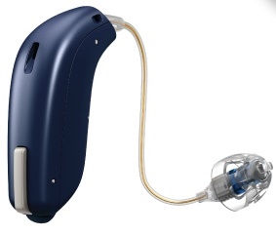

The Oticon Opn hearing aids provide natural, high quality, 360 degree sound and distinguish between speech and noise in loud environments. This hearing aid can be controlled using the Oticon ON app to adjust volume, change programs, view battery life and find a misplaced hearing aid.
Android users can stream sound directly to this hearing aid from any Bluetooth-enabled device by using the Connect Clip and can download the Oticon ON app from Google Play on devices operating with Android 7.0 (Nougat) or later.
Available at: Hearing Savers and Focus Hearing among other audiologists and audiometrists. You can also find an Oticon Supplier near you.
More information at:
Link to Oticon Opn
Link to Oticon Opn Product Guide (Download)
Link to Oticon Opn - Video Tutorials
Link to Oticon Opn - Compatibility

Phonak Audéo Marvel – Connects directly to Android Devices

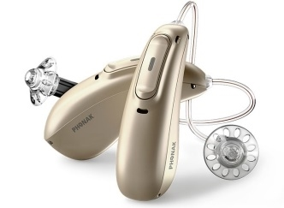
The Phonak Audéo Marvel provides clear, rich sound and adapts to a range of listening situations for greater speech clarity and less listening effort. This hearing aid can be controlled using the Phonak Remote app to adjust volume, change programs and make personalised changes, while the myPhonak app provides real-time communication, support and hearing aid adjustments.
This hearing aid also supports the Phonak myCall-to-Text app which transcribes audio from incoming phone calls in real-time into on-screen text for extra support and assurance during phone conversations.
The Phonak Audéo Marvel is the first hearing aid to support direct streaming from an Android device without needing an accessory, and Android users can download the Phonak apps from GooglePlay on selected devices using Android 6.0 or later. All Bluetooth-enabled devices can stream sound directly to the Phonak Audéo Marvel, including Apple devices.
Available at: Hearing Savers, Focus Hearing and Value Hearing among other audiologists and audiometrists. You can also find a Phonak Supplier near you.
More information at:
Link to Phonak Audéo Marvel
Link to Phonak Audéo Marvel Brochure (Download)
Link to Phonak Audéo Marvel - Video Tutorials

ReSound ENZO 3D - Connects to Android devices by using an additional phone clip

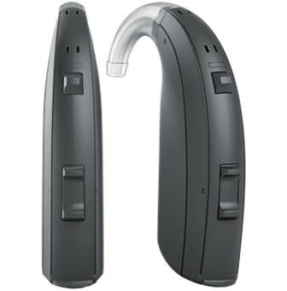

The ReSound ENZO 3D is for people with severe to profound hearing loss to make everyday hearing clear and crisp, with Spatial Sense technology for a natural sense of sounds. This hearing aid can be controlled using the ReSound Smart 3D app to adjust volume, change listening modes, find misplaced hearing aids, save automatic setting updates for favourite locations, and can be used to remotely update and alter your hearing aids by a professional.
Android users can stream sound directly to this hearing aid from any Bluetooth-enabled device by using the ReSound Phone Clip+ and can download the ReSound Smart 3D app from Google Play on selected Android devices.
Available at: Hearing Savers and Value Hearing among other audiologists and audiometrists. You can also find a ReSound Supplier near you.
More information at:
Link to ReSound ENZO 3D
Link to ReSound ENZO 3D - Support and Video Tutorials
Link to ReSound Smart 3D App - Compatibility

ReSound LiNX 3D – Connects to Android devices by using an additional phone clip

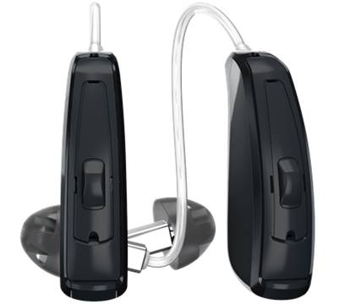
The ReSound LiNX 3D provides a 360 degrees sound experience to hear sound all around you and Spatial Sense technology for a natural sense of sounds. This hearing aid can be controlled using the ReSound Smart 3D app to adjust volume, change listening modes, find misplaced hearing aids, save automatic setting updates for favourite locations, and can be used to remotely update and alter your hearing aids by a professional.
Android users can stream sound directly to this hearing aid from any Bluetooth-enabled device by using the ReSound Phone Clip+ and can download the ReSound Smart 3D app from Google Play on selected Android devices.
Available at: Hearing Savers and Value Hearing among other audiologists and audiometrists. You can also find a ReSound Supplier near you.
More information at:
Link to ReSound LiNX 3D
Link to ReSound LiNX 3D Brochure (Download)
Link to ReSound LiNX 3D - Support and Video Tutorials
Link to ReSound Smart 3D App - Compatibility

ReSound LiNX Quattro - Connects to Android devices using an additional phone clip

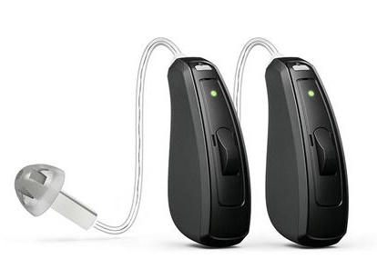
The ReSound LiNX provides speech and sound clarity from different directions in any environment. This hearing aid can be controlled using the ReSound Smart 3D app to adjust volume, change listening modes, find misplaced hearing aids, save automatic setting updates for favourite locations, and can be used to remotely update and alter your hearing aids by a professional.
Android users can stream sound directly to this hearing aid from any Bluetooth-enabled device by using the ReSound Phone Clip+ and can download the ReSound Smart 3D app from Google Play on selected Android devices.
Available at: Hearing Savers and Value Hearing among other audiologists and audiometrists. You can also find a ReSound Supplier near you.
More information at:
Link to ReSound LiNX Quattro
Link to ReSound LiNX Quattro Brochure (Download)
Link to ReSound LiNX Quattro - Support and Video Tutorials
Link to ReSound Smart 3D App - Compatibility

Signia Insio Nx ITC/ITE - Connects to Android devices by using an additional phone clip

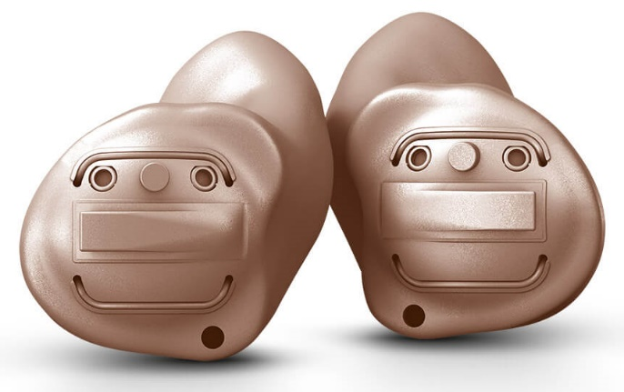

The Signia Insio Nx is tailor-made to fit inside the ear for maximum discretion and provides natural sound and superior speech understanding. This hearing aid can be controlled using the myControl app to adjust volume, personalise settings, change programs, view battery life, monitor noise exposure and voice activity for hearing health, utilise 360 degree microphone steering and switch to flight mode.
Android users can stream sound directly to this hearing aid from any Bluetooth-enabled device by using the StreamLine Mic and can download the myControl app from Google Play on selected Android devices.
Available at: True Hearing and Australian Hearing among other audiologists and audiometrists. You can also find a Signia Supplier near you.
More information at:
Link to Signia Insio Nx ITC/ITE
Link to Signia Made for iPhone Hearing Aids - Video Tutorials
Link to Signia myControl App - Android Compatibility

Signia Motion 13/13P Nx - Connects to Android devices by using an additional phone clip

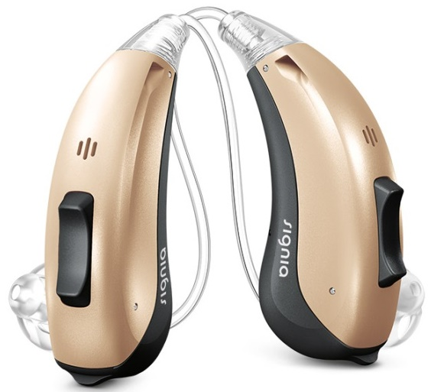
The Signia Motion 13 Nx provides speech clarity of both your own voice and the voice of others, and offers versatile fitting options. The Motion 13P is ideal for those with individual fitting requirements with greater hearing loss. This hearing aid can be controlled using the myControl app to adjust volume, personalise settings, change programs, view battery life, monitor noise exposure and voice activity for hearing health, utilise 360 degree microphone steering and switch to flight mode.
Android users can stream sound directly to this hearing aid from any Bluetooth-enabled device by using the StreamLine Mic and can download the myControl app from Google Play on selected devices.
Available at: Australian Hearing, Hearing Savers, Focus Hearing and Value Hearing among other audiologists and audiometrists. You can also find a Signia Supplier near you.
More information at:
Link to Signia Motion 13/13P Nx
Link to Signia Made for iPhone Hearing Aids - Video Tutorials
Link to Signia myControl App - Android Compatibility

Signia Pure 13 BT primax - Connects to Android devices by using an additional phone clip

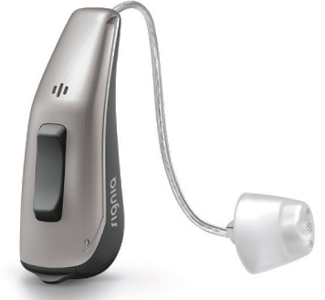
The Signia Pure 13 BT primax provides an optimal personalised hearing experience in challenging, noisy environments. This hearing aid can be controlled using the myControl app to adjust volume, personalise settings, change programs, view battery life, monitor noise exposure and voice activity for hearing health, utilise 360 degree microphone steering and switch to flight mode.
Android users can stream sound directly to this hearing aid from any Bluetooth-enabled device by using the StreamLine Mic and can download the myControl app from Google Play on selected devices.
Available at: Australian Hearing and Value Hearing among other audiologists and audiometrists. You can also find a Signia Supplier near you.
More information at:
Link to Signia Pure 13 BT primax
Link to Signia Made for iPhone Hearing Aids - Video Tutorials
Link to Signia myControl App - Android Compatibility

Signia Pure 13 Nx - Connects to Android devices by using an additional phone clip

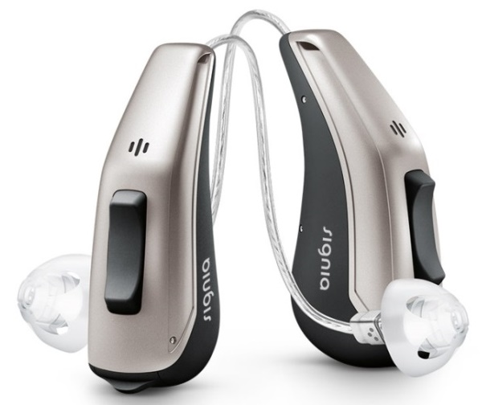
The Signia Pure 13 Nx provides speech clarity of both your own voice and the voice of others, with a long-life battery built for streaming. This hearing aid can be controlled using the myControl app to adjust volume, personalise settings, change programs, view battery life, monitor noise exposure and voice activity for hearing health, utilise 360 degree microphone steering and switch to flight mode.
Android users can stream sound directly to this hearing aid from any Bluetooth-enabled device by using the StreamLine Mic and can download the myControl app from Google Play on selected devices.
Available at: Australian Hearing, Focus Hearing and Value Hearing among other audiologists and audiometrists. You can also find a Signia Supplier near you.
More information at:
Link to Signia Pure 13 Nx
Link to Signia Made for iPhone Hearing Aids - Video Tutorials
Link to Signia myControl App - Android Compatibility

Signia Pure 312 Nx - Connects to Android devices by using an additional phone clip

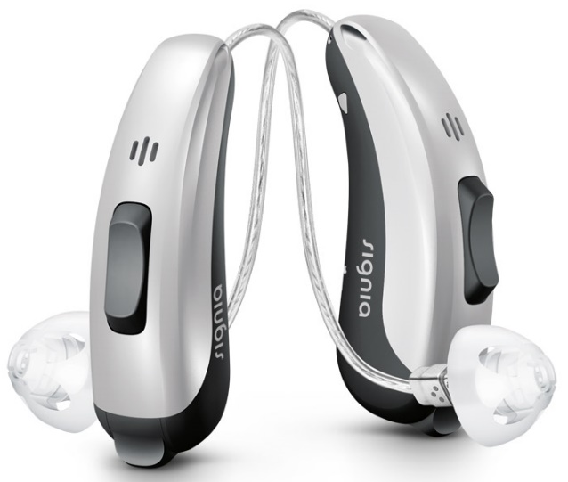
The Signia Pure 312 Nx is a small, compact hearing aid and provides speech clarity of both your own voice and the voice of others. This hearing aid can be controlled using the myControl app to adjust volume, personalise settings, change programs, view battery life, monitor noise exposure and voice activity for hearing health, utilise 360 degree microphone steering and switch to flight mode.
Android users can stream sound directly to this hearing aid from any Bluetooth-enabled device by using the StreamLine Mic and can download the myControl app from Google Play on selected devices.
Available at: Australian Hearing, Focus Hearing and Value Hearing among other audiologists and audiometrists. You can also find a Signia Supplier near you.
More information at:
Link to Signia Pure 312 Nx
Link to Signia Made for iPhone Hearing Aids - Video Tutorials
Link to Signia myControl App - Android Compatibility

Signia Pure Charge&Go Nx - Connects to Android devices by using an additional phone clip

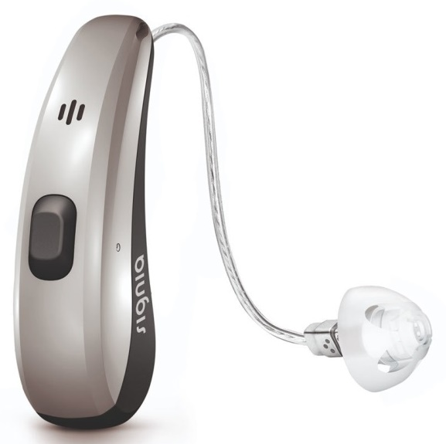
The Signia Pure Charge&Go Nx provides speech clarity of both your own voice and others and is wirelessly recharged without the need for disposable batteries. This hearing aid can be controlled using the myControl app to adjust volume, personalise settings, change programs, view battery life, monitor noise exposure and voice activity for hearing health, utilise 360 degree microphone steering and switch to flight mode.
Android users can stream sound directly to this hearing aid from any Bluetooth-enabled device by using the StreamLine Mic and can download the myControl app from Google Play on selected devices.
Available at: Australian Hearing, Hearing Savers and Focus Hearing among other audiologists and audiometrists. You can also find a Signia Supplier near you.
More information at:
Link to Signia Pure Charge&Go Nx
Link to Signia Made for iPhone Hearing Aids - Video Tutorials
Link to Signia myControl App - Android Compatibility

Widex BEYOND Hearing Aids - Connects to Android devices by using an additional phone clip

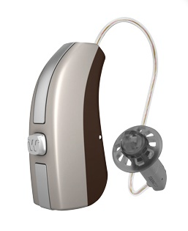
Widex BEYOND hearing aids optimize sound based on your environment and feature a SMARTWIND Manager which reduces wind noise annoyance while increasing speech understanding. This hearing aid can be controlled using the BEYOND app to adjust sound and listening preferences, create sound templates for specific listening situations, alter microphone direction, personalisation and to find a misplaced hearing aid.
Although this is a Made for iPhone hearing aid, some Android users can stream sound directly to this hearing aid from any Bluetooth-enabled device by using the Widex COM-DEX and can download the BEYOND app from Google Play on selected Android devices.
Available at: Hearing Savers, and Value Hearing among other audiologists and audiometrists. You can also find a Widex Supplier near you.
More information at:
Link to Widex BEYOND Hearing Aids
Link to Widex BEYOND - Support and Video Tutorials
Link to BEYOND app - Compatibility

Is there any training available for these accessories?
Training and demonstrations might be available directly from hearing aid retailers and audiology clinics.

