Sip/Puff, Breath-activated and Pneumatic Switches
Sip/Puff, Breath-activated and Pneumatic Switches allow people with physical disabilities to activate assistive technology and mainstream devices in their environment, such as smartphones, tablets and computers.
These switches might be helpful for persons who do not have any upper-body mobility resulting from spinal cord injuries, multiple sclerosis, ALS, muscular dystrophy, cerebral palsy, brain injuries, stroke, or amputation.
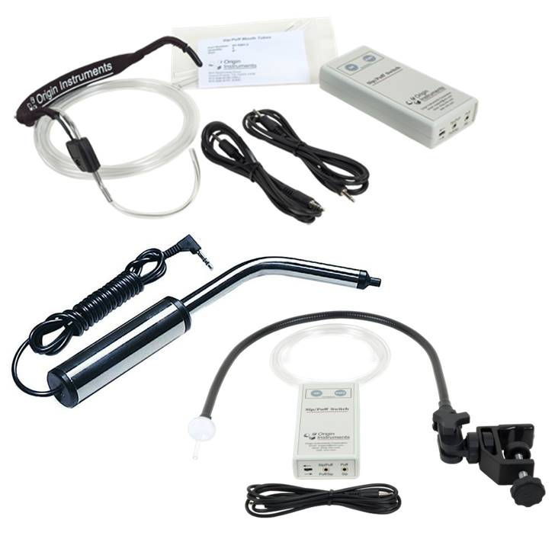
Type of accessory: Ability Switches

How do you use these accessories?
Place the straw, tube or wand on your mouth and then “Sip” (inhale) or "puff" (exhale). Each sip or puff can carry a switch action that allows you to access apps and functions in your smart device, including call and messaging services.
These switches need to be connected to a Bluetooth Switch Interface in order to connect to a phone or tablet.

These accessories connect to phones via:
Audio Jack: No
Bluetooth: Yes (Using a Bluetooth switch interface)
Wi-Fi: No
Micro USB: No
Other: No

Is there any other piece of equipment required for this accessory to work properly with a phone?
Yes. These switches do not have Bluetooth connectivity, which is usually required to connect to a smartphone or tablet; therefore you need a “Bluetooth Switch Interface” which is a device that acts as a connection bridge between your corded switch and your smartphone or tablet.
Some Bluetooth switch interfaces in the market are Tecla Shield DO, Tecla e and Pretorian Applicator switch interface.
Also, these switches usually require a mounting system to stay in place when operated.

Compatibility:
The compatibility of these switches depends on the Bluetooth Switch Interface used to connect to the phone or tablet.

Sip/Puff, Breath-activated and Pneumatic Switches available in Australia:

AbleNet Pneumatic Dual Switch
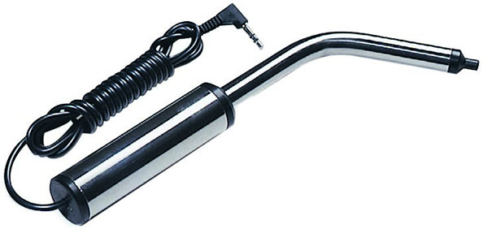
The Pneumatic Switch is a sip and puff switch. It has a dual switch action, to activate one switch the user "sips" and to activate the other switch the user "puffs". An internal saliva trap allows for ease of cleaning.
Main features:
- Long Pneumatic Switch size: 2.5cm x 40cm (1”x 16”)
- Activating Force: 3” w/c(g)
- Current: 30VDC max 30mA
- Mounting Plate: Pneumatic Switch Clamp Connector

More information at: Ablenet Pneumatic Dual Switch at Spectronics
You can buy this accessory online from Spectronics

Origin Instruments Sip/Puff Switch with Headset

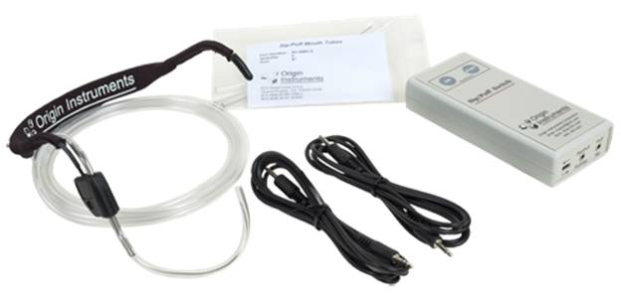
The Sip/Puff Switch translates sips and puffs into independent switch closures. The Sip/Puff Switch has two 3.5mm ports for connecting two standard mono cables or a single stereo cable. It also has integrated test buttons to assist in application testing.
Sip/Puff Headset is a comfortable, adjustable head frame. The padded headset slips over the ears and behind the head. A replaceable mouth tube is held in position with an integral stainless steel forming wire. The tube and wire can be bent and cut to adapt to individual needs.
More information at: Origin Instruments Sip/Puff Switch website
You can buy this accessory online from Spectronics

Origin Instruments Sip/Puff Switch with Gooseneck
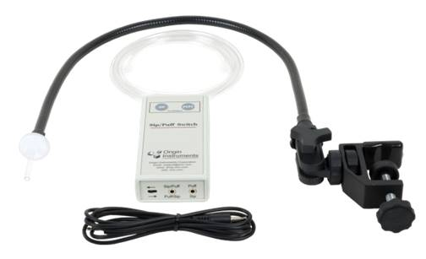
The Sip/Puff Switch translates sips and puffs into independent switch closures. The Sip/Puff Switch has two 3.5mm ports for connecting two standard mono cables or a single stereo cable. It has integrated test buttons to assist in application testing.
Strong, lightweight and versatile, the Sip/Puff Gooseneck features a Universal Mount that securely attaches to table tops, beds and wheelchairs. The flexible steel gooseneck and the ball-and-socket mount allows for easy and secure mouthpiece positioning. The filtered mouthpiece is replaceable and a thin, pliable connecting tube interfaces the mouthpiece to the Sip/Puff Switch with a simple twist connector.
More information at: Origin Instruments Sip/Puff Switch website
You can buy this accessory online from Spectronics

Q UHA Sento MP Switch
The Quha Sento MP is a contactless Puff Switch (No “sip” action). This switch is mounted or head worn and is activated small puff of air or even a gentle "P" sound.
More information at: Quha Sento MP Page at Zyteq
Available at: Zytec

Technical Solution Sip/Puff Switch
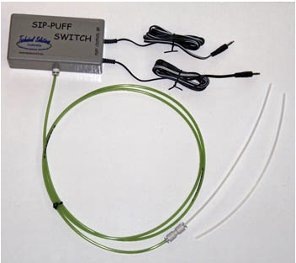
These switches will activate a toy or device by sipping OR puffing through the air tube. Sipping on the tube will operate one device, while puffing on the same tube will cause a second device to operate.
The tube we use for this switch can be accurately positioned using the flexible mounts and clamps also available at Technical Solutions.
You can buy this accessory online from Technical Solutions Australia

Zyteq Sip Puff Switch
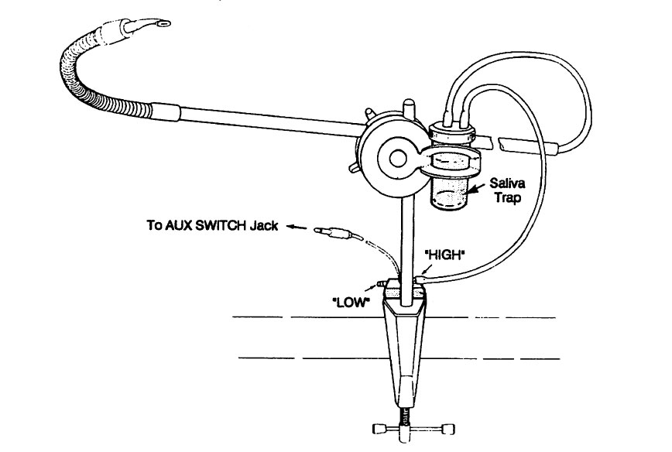
The Zytec sip puff switch permits activations through use of oral air and includes a mounting hardware. The sip puff switch is complete with mouth piece, saliva trap (sputum collector), surgical tubing inside a gooseneck, and metal rods. It is connected by an x-joint and mountable using a 10mm mount and G-clamp.
Main features:
- Single function - set to sip OR puff actuation
- Length of gooseneck: 30 cm
- Length of gooseneck and rod: 80 cm
- 3.5 mm phono plug
You can buy this accessory online from Zytec

Is there any training available for these accessories?
Training and demonstrations might be available directly from the retailers.
Some of these accessories might be displayed and available for demonstrations at Independent Living Centre Australia. Please contact ILC by calling 1300 885 886 for further information.

