Type and Listen Calls

Type and Listen Calls are ideal if you have difficulty speaking or communicating on the phone, can hear adequately, and don't use a computer or mobile phone.
You type your message and listen to the responses.
Use a TTY (telephone typewriter)

How it works
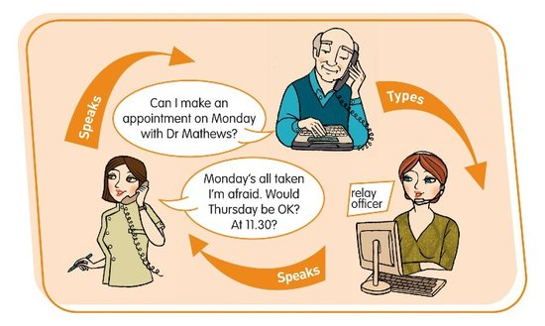
In this type of call you type your side of the conversation on your TTY keyboard and the relay officer reads it aloud to the other person on their phone. You then listen to the other person speak directly to you.
Relay officers are the central link in the phone call. They stay on the line throughout each call to help it go smoothly, but do not change or interfere with what each person says.

Equipment
You will need a specialised fixed-line phone known as a TTY.
A TTY has a keyboard where you can type your side of the message. (There is also and a small display screen for users who can't hear and need to read the responses.)
The main model of TTY for Type and Listen calls is the Uniphone, a combined TTY and telephone.
In most cases you can rent a TTY for about the same cost as an ordinary phone through the disability equipment schemes offered by Telstra and Optus.

Adding a speakerphone to your TTY
You may find it more convenient to have a speakerphone connected to your TTY so you don't have to hang up the receiver each time you type. (Note that you will have to turn off the speaker button each time to prevent "jumbling" of your messages.)
It is possible to use a Superprint TTY and speakerphone together on some phone lines only. However it does not work in all situations and we recommend that you trial it first.
You may be able to rent a speakerphone from your telephone company for the same cost as a standard phone.

Other equipment
You might find other equipment useful, such as a phone arm, flashing light or phone double adaptor. This will depend on your personal requirements.
Contact the NRS Helpdesk for more information on disability equipment schemes, and where to obtain TTYs and other specialised equipment that you might need.

What does it cost?
Relay calls within Australia are free. However you will be connecting to the internet and charges for your data use will depend on your internet or mobile data plan.
If you want to make calls to phone numbers overseas or premium rate (1900) calls you will need a prepaid phone card or an NRS account.

Further information and useful links:
Type and Listen Calls
How to make a Type and Listen call - You Tube video
Calling a NRS User

*The information contained in this document comes from the National Relay Service Australia.

