National Relay Service (NRS) Application
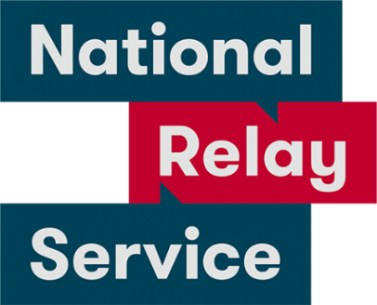
The National Relay Service can be accessed through the NRS App, allowing any Australian who is Deaf, hearing impaired or speech impaired to make and receive phone calls on their smartphone or tablet. The app provides easier ways to make calls through the NRS in Australia via the support of a relay officer.

Features:
The NRS app allows user to access several call options, including NRS Chat, Voice Relay, Video Relay and NRS Captions.
It also offers extra features for NRS Chat and Voice Relay users:
- Saving messages for different services which need to be used during a call
- Saving Quick Phrases, personal details and contact information to insert into calls
- Sending location details using the GPS function.
When you wish to place a call, you can open the app and follow instructions to select your desired relay officer support.

Instruction Sheets on using NRS App:

NRS Chat
- Making a call Instruction Sheet (PDF Download)
- Answering a call Instruction Sheet (PDF Download)
- Call to emergency services Instruction Sheet (PDF Download)

NRS Captions
- Making a call Instruction Sheet (PDF Download)
- Answering a call Instruction Sheet (PDF Download)
- Call to emergency services Instruction Sheet (PDF Download)

Voice Relay
- Making a call Instruction Sheet (PDF Download)
- Answering a Call Instruction Sheet (PDF Download)
- Call to emergency services Instruction Sheet (PDF Download)

App Details:

Compatibility:
- Apple: iOS 7.0 or later
- Android: OS 4.0 and up

Price:
The app and any calls you make using the app are free. However, you will be connecting to the internet and will be using broadband data. How you are charged for this data will depend on the plan you have with your service provider.

More Information at:
Access Hub - NRS website
NRS App Fact Sheet (Download)
You can download this application from the Apple App Store or the Google Play Store.

