Internet Relay
Internet Relay calls are ideal if you are deaf, have difficulty hearing or using your voice. The service only requires an internet connection.
This is a text-based relay call using the internet, so you type your messages and read the responses.
Use a computer, laptop, tablet or smartphone.

How it works
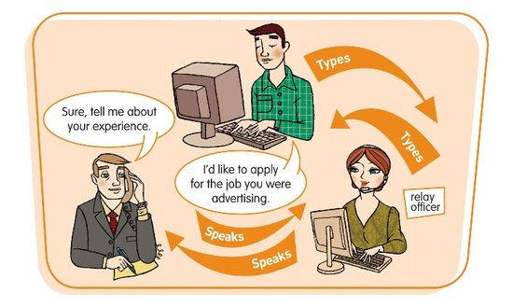
In this type of call, you communicate with the relay officer by sending messages online via the relay service website or app. Then, the relay officer calls and reads your message to the person you are trying to call, and then types their answers back to you, so you can read them on your screen.

Equipment
You need a computer, laptop, tablet or smartphone that allows you to make a connection to the internet - either through the NRS app or NRS website.

Minimum operating requirements for a computer:
PC: Windows Vista or later with 1GHz 32-bit (x86) processor or 1GHz 64-bit (x64) processor
Mac: OS X 10.4 or later
Memory: A recommended minimum of 1GB of system memory and 128MB of graphics memory

Internet browser:
- Chrome 14 or above
- Internet Explorer 8 or above
- Firefox 7 or above
- Safari 5.1 and above.

Phones and Tablets:
- Apple iOS 7.0 and up
- Android OS 4.0 or later
For instructions on using the NRS app, please see the Making a Call, Answering a Call, and Call to Emergency Services Fact Sheets.

What does it cost?
Relay calls within Australia are free. However you will be connecting to the internet and charges for your data use will depend on your internet or mobile data plan.
If you want to make calls to phone numbers overseas or premium rate (1900) calls you will need a prepaid phone card or an NRS account.

Further information and useful links:
Internet Relay Fact Sheet
Internet Relay Call Web Page
NRS Service Features Web Page
Making an Internet Relay Call Instruction Sheet
Answering an Internet Relay Call Instruction Sheet
Numbers for calling an NRS User
NRS APP – Apple APP Store
NRS APP- Google Play Store

*The information contained in this document comes from the National Relay Service Australia.

